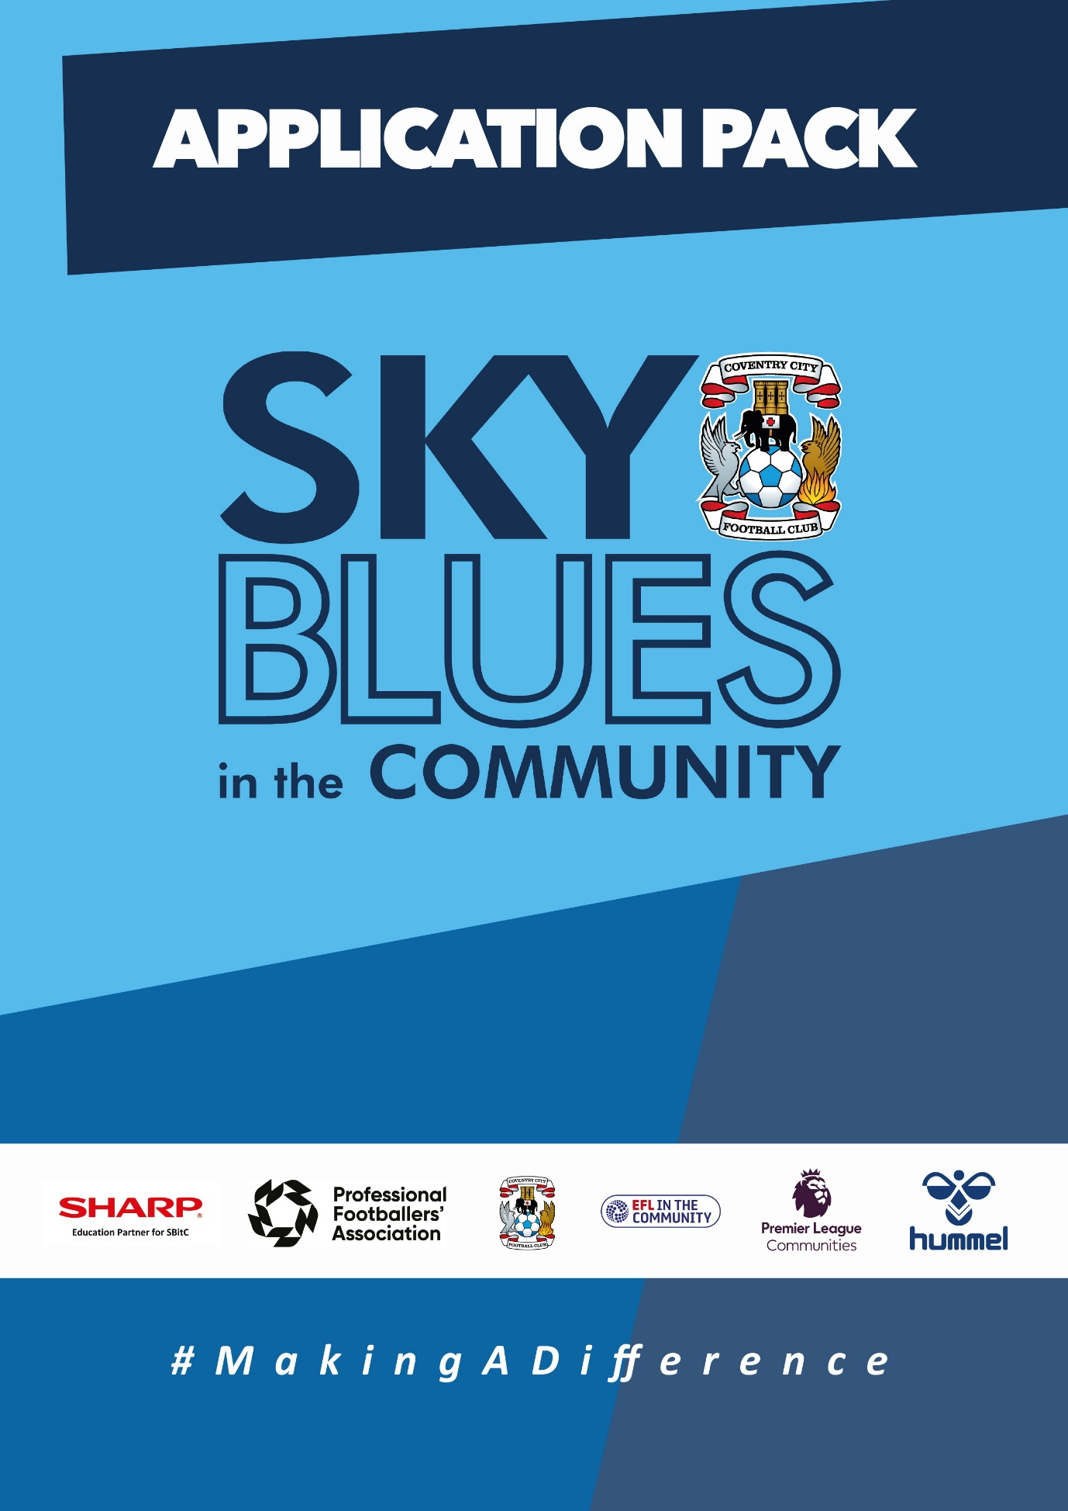

APPLICATION PACK
ABOUT US
Sky Blues in the Community is the official charity of Coventry City Football Club, proudly based at the Coventry Building Society Arena. Our mission is to harness the power of sport and physical activity, leveraging the unique influence and appeal of Coventry City Football Club to deliver impactful, high-quality community programs. Through strong partnerships and strategic alliances, we aim to empower individuals and communities across Coventry and Warwickshire.
Our work is driven by a commitment to social change and community empowerment. We provide inclusive and accessible opportunities to improve health and wellbeing, promote social inclusion, reduce crime, and enhance access to education and employment. Through these efforts, we aim to #MakeADifference across our city and county.
OUR STRATEGIC THEMES
Our work is structured around five core thematic areas, each with a distinct mission:
1. Health and Wellbeing
We are committed to addressing the health inequalities facing some of Coventry and Warwickshire’s most underrepresented communities. Through engaging, evidence-based programs, we support individuals to live healthier, happier lives, standing in partnership with organisations that share our vision for community wellbeing.
2. Education, Skills and Training
We aim to play a leading role in improving access to education, training, and employment opportunities. By inspiring confidence, providing practical tools and tailored support, we help individuals progress towards sustainable careers and lifelong learning.
3. Inclusion, Engagement and Participation
We are passionate about creating an active, inclusive, and cohesive community. Our programs provide opportunities for everyone—regardless of background, ability, or circumstance—to engage in physical activity in a welcoming, non-judgmental, and inspiring environment.
4. Sports Facilities and Community Assets
We are committed to enhancing the availability and quality of community spaces for sport and physical activity. By responding to the unique needs of our communities, we champion equitable access to inclusive, safe, and high-quality facilities that promote healthy lifestyles and social connection.
5. People and Infrastructure
Our people are our greatest asset. To sustain and grow our impact, we are investing in our team and our organisational infrastructure. We aim to ensure our workforce is reflective of our community and supported by continuous learning and development. We are committed to fostering a high-performing, inclusive, and purpose-driven working environment where everyone can thrive.

OUR VALUES
We expect all staff to embody our core values in everything they do:
- Community Focused
- Passionate
- Innovative
- Ambitious
- Inclusive

EQUALITY, DIVERSITY & INCLUSION
Sky Blues in the Community is committed to promoting equality, diversity, and inclusion across our workforce, services, and programs. We are dedicated to creating an environment where all individuals feel welcomed, respected, and empowered to reach their potential. We strive to embed inclusive practices throughout the organisation and challenge inequality wherever it arises.
SAFEGUARDING STATEMENT
We operate a person-centered approach to safeguarding. Where there are concerns about the welfare of a child or an adult at risk, we act in their best interests at all times. Sky Blues in the Community fully accepts its responsibility for safeguarding the wellbeing and safety of all individuals involved in our programs. All staff have a duty to create a safe, inclusive environment that protects children and adults at risk from harm. Safeguarding is everyone’s responsibility.



JOB DESCRIPTION
Job Title: | Football Development Coordinator – Part time OR Job Share | Reporting to: | Football Development Project Manager
Salary: | £13,500 per annum, based on 20 hours per week (£27,000 full-time equivalent) | Contract Type: | Part time, permanent  Note: this can be a job share
Location: | President Kennedy’s School, CBS arena and various across Coventry | Days and hours of work: | 20 hours per week. The role will normally include three evenings per week, with start times between 5.00pm and 6.00pm and finish times up to 9.00pm, plus Saturday mornings from 9.00am to 1.00pm.  Flexible working: Job-share arrangements or reduced-hour arrangements may be considered where the required evening and Saturday cover can be met. Salary would be calculated pro rata where fewer than 20 hours are agreed.
Document created: | Jul2026 | Reference number: | PTFDC

Purpose of the role:

The Football Development Coordinator will support the effective delivery of Sky Blues in the Community’s football development provision during evenings and Saturdays.
The postholder will help ensure that sessions are properly staffed, safe, organised and delivered to a high standard. The role will provide on-site coordination, coach support, parent and participant communication, safeguarding oversight and administrative support across player development centres and wider football development programmes.
This role is designed to strengthen evening and weekend provision by ensuring that delivery staff, including casual coaches, are supported and that facilities are appropriately covered by a member of SBitC staff.
Key responsibilities (but not completely exclusive to):

- Support the planning, coordination and delivery of evening and Saturday football development provision, including player development centres and wider football development activity.
- Provide on-site coordination during agreed evening and Saturday sessions, ensuring facilities, equipment, registers, staffing and session arrangements are in place.
- Support casual coaches during delivery, including confirming attendance, communicating session requirements and helping ensure expected coaching and conduct standards are maintained.
- Deliver coaching sessions where required, in line with the agreed Player Development Centre curriculum, coaching methodology and programme standards.
- Support the Football Development Project Manager with the implementation of session plans, curriculum requirements, player development processes and quality standards.
- Act as a point of contact for parents, carers, players, coaches and facility partners during evening and Saturday provision, ensuring communication is clear, professional and timely.
- Maintain accurate programme records, including attendance registers, incident records, safeguarding information, session updates, equipment checks and other required documentation.
- Ensure safeguarding, welfare, health and safety and behaviour expectations are followed at all times, escalating concerns promptly in line with SBitC policies and procedures.
- Support player engagement, confidence, enjoyment and progression by helping to create a positive, inclusive and well-managed football environment.
- Assist with fixtures, tournaments, holiday programmes, events and wider football development activity where required and within agreed working hours.
- Support the monitoring and review of programme delivery by providing feedback on session quality, staffing, player experience and operational issues.
- Maintain compliance with organisational policies and procedures, including safeguarding, equality, diversity and inclusion, health and safety, data protection and FA requirements.
- Carry out any other duties reasonably required in line with the nature and level of the role.

PERSON SPECIFICATION
Job Title: Football Development Coordinator
1. Qualifications and training
Essential
- FA Level 2 in Coaching, UEFA C, or equivalent relevant coaching qualification.
- Up-to-date Safeguarding and First Aid Qualifications
Willingness to undertake further training relevant to the role.
Desirable
- FA Level 3 / UEFA B or working towards this qualification.
- Talent identification or player development qualification.
- Qualification or training in sports development, education, youth work or a related area.
- Full UK driving licence and access to a suitable vehicle for work purposes.
2. Experience
Essential
- Experience of delivering football coaching sessions to children or young people.
- Experience of working in a football, sport, school, community or youth development environment.
- Experience of supporting safe, organised and inclusive session delivery.
- Experience of communicating with parents, carers, young people, coaches or partners.
- Knowledge and understanding of safeguarding responsibilities when working with children and young people.
Desirable
- Experience of working in player development centres, grassroots football, academy, emerging talent or girls’ football environments.
- Experience of coordinating or supporting casual coaches, volunteers or sessional staff.
- Experience of evening or weekend sports programme delivery.
- Experience of using attendance records, registers, incident forms or programme monitoring systems.
3. Skills and abilities
- Strong organisational skills and ability to manage practical delivery arrangements.
- Ability to work confidently during evening and weekend sessions.
- Good communication skills with children, young people, parents, carers, coaches and partners.
- Ability to remain calm and professional when dealing with operational issues.
- Ability to follow agreed coaching plans, curriculum requirements and programme standards.
- Ability to work independently on site while knowing when to escalate issues.
- Basic IT and administration skills, including accurate record keeping.
- Commitment to providing a positive experience for all participants.
4. Behaviours
- Acts with integrity, confidentiality and professionalism at all times.
- Resilient and composed when dealing with challenging behaviours.
- Positive, approachable manner with a genuine “can do” attitude.
- Passionate about inclusion and making a difference in young people’s lives.
- Enthusiastic, energetic and adaptable under pressure.
- Commitment to safeguarding, equality, diversity and inclusion.

APPLICATION INFORMATION
Do you want to support young players in a safe, positive and well-organised football environment?Sky Blues in the Community, the official charity of Coventry City Football Club, is recruiting a part-time Football Development Coordinator to support our evening and Saturday football development provision across Coventry and Warwickshire. This is a practical, delivery-focused role which sits at the heart of our Player Development Centre and wider football development activity. The role will suit someone who enjoys football, working with young people, supporting coaches and making sure sessions are properly organised, safe and delivered to a high standard.
Why this role matters
A significant amount of our football development work takes place in the evenings and at weekends. These sessions need strong organisation, reliable site cover, clear communication, accurate registers, safeguarding oversight and support for the coaches delivering on the ground.
This role provides that structure. You will support the Football Development Project Manager and work alongside coaches, casual staff, parents, carers and facility partners to make sure sessions run professionally and that young players have positive experience.

What makes this opportunity unique

This is a part-time role built around evening and Saturday provision. It may suit someone who is already working, studying or coaching elsewhere and is looking for a meaningful role in football development outside standard office hours.

The role is 20 hours per week, normally including three evenings per week and Saturday mornings. Job-share arrangements may be considered where the required evening and Saturday cover can still be met.

You will be part of the official charity of Coventry City Football Club, supporting football provision that helps children and young people develop their skills, confidence, discipline and enjoyment of the game.

What you will do
You will help coordinate and support evening and Saturday football development sessions, including Player Development Centre activity and wider football development programmes.
Your responsibilities will include:
• supporting session set-up and site coordination;
• ensuring registers, equipment and operational arrangements are in place;
• supporting casual coaches and delivery staff during sessions;
• delivering coaching sessions where required;
• helping ensure sessions follow the agreed curriculum and coaching methodology;
• communicating professionally with parents, carers, players, coaches and facility partners;
• maintaining accurate records, including attendance, incidents and safeguarding information;
• escalating safeguarding, welfare or operational concerns promptly; and
• supporting a positive, inclusive and well-managed environment for young players.

What we are looking for

We are looking for someone with experience of coaching football and working with children or young people. You will need to be organised, reliable and confident in a delivery environment.

You do not need to be a senior manager, but you do need to understand what good session delivery looks like and be able to support others to maintain standards. You should be comfortable taking responsibility for practical arrangements during evening and Saturday provision and communicating clearly with parents, carers, coaches and players.

A strong understanding of safeguarding is essential. Experience of player development centres, grassroots football, girls’ football, community sport or youth football would be an advantage.

How to Apply
To apply, please submit either:
- A CV and covering letter or
- A completed application form
Your application should clearly demonstrate how you meet the criteria outlined in the person specification.
Please send your application to: Shaun Pierce at recruitment@sbitc.org.uk
Please note: You only need to submit either a CV and covering letter or a completed application form, not both.
Closing date for applications: 3rd of August 2026
Please note that we may close the application process early if we receive a high number of applications, so early applications are encouraged.
If you require the application form in an alternative format, or if you would like to apply using a different method due to a disability or accessibility need, please contact us via 024 7678 6349 and we will be happy to discuss reasonable adjustments.
Safer Recruitment and Pre-Employment Checks
At Sky Blues in the Community, safeguarding is central to everything we do. We are committed to creating a safe and supportive environment for all staff, volunteers, and participants.
This role may involve working with children or adults at risk, and as part of our safer recruitment process, any offer of employment will be subject to:
- Two satisfactory references
- An enhanced Disclosure and Barring Service (DBS) check
- Confirmation of your identity and right to work in the UK

All staff are expected to follow our Safeguarding Policies and complete relevant training as part of their induction and ongoing professional development.
Diversity and Inclusion
Sky Blues in the Community is an equal opportunities employer. We welcome applications from all sections of the community and particularly encourage applications from individuals who are underrepresented in the sport and charity sectors. Appointments are made strictly on merit.
We are committed to providing an inclusive recruitment process. If you require any adjustments to complete your application or to attend an interview, please let us know.
We may collect anonymised equalities data from applicants for monitoring purposes only. This data will not form any part of the recruitment decision-making process.
Privacy Notice
Sky Blues in the Community is committed to handling your personal information responsibly and transparently. We comply with the UK General Data Protection Regulation (UK GDPR) and the Data Protection Act 2018 to ensure the privacy and security of your data.
Information provided during the recruitment process will be stored securely and retained for a period of six months after the closing date of the vacancy, unless a longer period is required by law or you consent to us retaining your details for future opportunities.
To request a copy of our privacy notice or exercise your data rights, please contact: sbitc@sbitc.org.uk.

