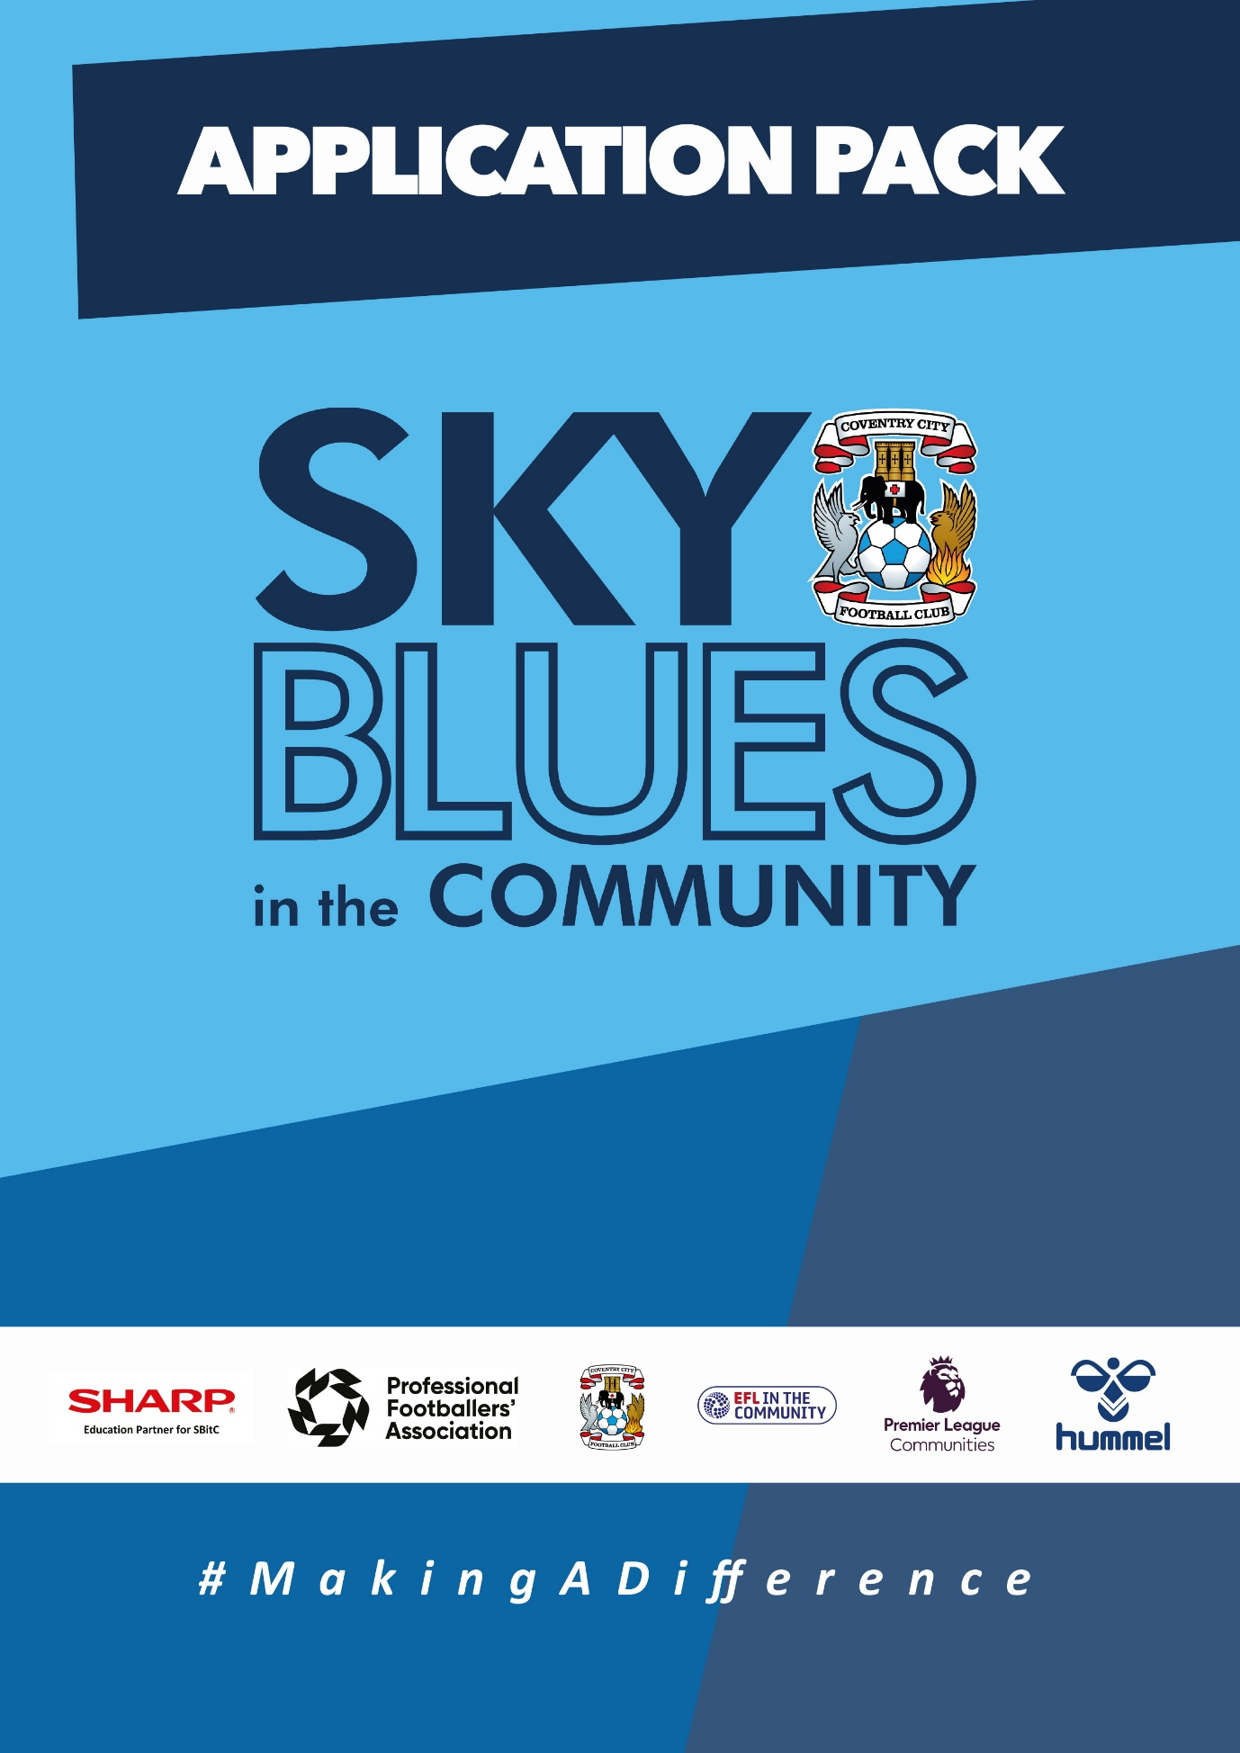

APPLICATION PACK
ABOUT US
Sky Blues in the Community is the official charity of Coventry City Football Club, proudly based at the Coventry Building Society Arena. Our mission is to harness the power of sport and physical activity, leveraging the unique influence and appeal of Coventry City Football Club to deliver impactful, high-quality community programs. Through strong partnerships and strategic alliances, we aim to empower individuals and communities across Coventry and Warwickshire.
Our work is driven by a commitment to social change and community empowerment. We provide inclusive and accessible opportunities to improve health and wellbeing, promote social inclusion, reduce crime, and enhance access to education and employment. Through these efforts, we aim to #MakeADifference across our city and county.
OUR STRATEGIC THEMES
Our work is structured around five core thematic areas, each with a distinct mission:
1. Health and Wellbeing
We are committed to addressing the health inequalities facing some of Coventry and Warwickshire’s most underrepresented communities. Through engaging, evidence-based programs, we support individuals to live healthier, happier lives, standing in partnership with organisations that share our vision for community wellbeing.
2. Education, Skills and Training
We aim to play a leading role in improving access to education, training, and employment opportunities. By inspiring confidence, providing practical tools and tailored support, we help individuals progress towards sustainable careers and lifelong learning.
3. Inclusion, Engagement and Participation
We are passionate about creating an active, inclusive, and cohesive community. Our programs provide opportunities for everyone—regardless of background, ability, or circumstance—to engage in physical activity in a welcoming, non-judgmental, and inspiring environment.
4. Sports Facilities and Community Assets
We are committed to enhancing the availability and quality of community spaces for sport and physical activity. By responding to the unique needs of our communities, we champion equitable access to inclusive, safe, and high-quality facilities that promote healthy lifestyles and social connection.
5. People and Infrastructure
Our people are our greatest asset. To sustain and grow our impact, we are investing in our team and our organisational infrastructure. We aim to ensure our workforce is reflective of our community and supported by continuous learning and development. We are committed to fostering a high-performing, inclusive, and purpose-driven working environment where everyone can thrive.

OUR VALUES
We expect all staff to embody our core values in everything they do:
- Community Focused
- Passionate
- Innovative
- Ambitious
- Inclusive

EQUALITY, DIVERSITY & INCLUSION
Sky Blues in the Community is committed to promoting equality, diversity, and inclusion across our workforce, services, and programs. We are dedicated to creating an environment where all individuals feel welcomed, respected, and empowered to reach their potential. We strive to embed inclusive practices throughout the organisation and challenge inequality wherever it arises.
SAFEGUARDING STATEMENT
We operate a person-centered approach to safeguarding. Where there are concerns about the welfare of a child or an adult at risk, we act in their best interests at all times. Sky Blues in the Community fully accepts its responsibility for safeguarding the wellbeing and safety of all individuals involved in our programs. All staff have a duty to create a safe, inclusive environment that protects children and adults at risk from harm. Safeguarding is everyone’s responsibility.

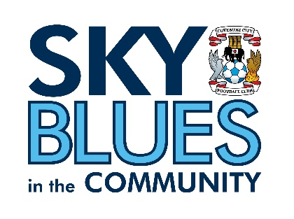

JOB DESCRIPTION
Job Title: | Football Development Project Manager | Reporting to: | Football Development Manager
Salary: | £31,000 | Contract Type: | Full time, permanent
Location: | President Kennedy’s School, CBS arena and various across Coventry | Days and hours of work: | 37.5 hours a week in any 5 out of 7 days. This role will involve evening and weekend work aligned to training, fixtures and programme delivery directly or via reporting staff. Travel across Coventry and Warwickshire will be required.
Document created: | Jul2026 | Reference number: | FDPM

Purpose of the role:

The Football Development Project Manager will oversee and support the delivery, development and quality assurance of Sky Blues in the Community’s football development provision across Coventry and Warwickshire.
The postholder will manage key staff within the football development structure, including the Female Football Development Coordinator and the part-time Football Development Coordinator supporting evening and Saturday delivery. This role will ensure that programmes are safe, inclusive, well planned, financially sustainable and aligned with organisational, safeguarding and FA requirements.
The role will have responsibility for programme planning, staff coordination, quality assurance, player development, facility cover, stakeholder relationships, monitoring and reporting. A key part of the role will be to ensure that evening and weekend football activity is appropriately staffed, supervised and delivered to a consistently high standard.
Key responsibilities (but not completely exclusive to):

- Lead, oversee and support the delivery of football development programmes across Sky Blues in the Community, ensuring sessions are safe, inclusive, well planned and aligned with agreed coaching and player development principles.
- Line manages the Female Football Development Coordinator, Football Development Coordinator and relevant casual coaches, ensuring clear workload planning, supervision, support, performance management and communication.
- Oversee the planning, staffing and operational delivery of football development provision, including evenings and Saturdays, ensuring appropriate site cover, safeguarding oversight, facility arrangements and programme standards are in place.
- Manage and support delivery across player development centres, female football provision, emerging talent activity and wider football participation programmes, ensuring provision is inclusive, high quality and aligned with agreed coaching and player development principles.
- Support the development and review of coaching curricula, session standards and player development pathways, including talent identification, player progression and coach feedback.
- Ensure all programmes are delivered in accordance with FA requirements, safeguarding, welfare, health and safety, equality, data protection and organisational policies.
- Maintain effective programme administration, including registers, rotas, session planning, equipment, communications, reporting, attendance, outcomes, safeguarding records and impact data.
- Build and maintain positive relationships with schools, clubs, parents, carers, facility partners, the FA and other stakeholders to support recruitment, progression and programme quality.
- Monitor resources and programme budgets where required, following organisational financial procedures and supporting sustainable delivery.
- Identify opportunities to improve and grow football development provision across Coventry and Warwickshire, supporting wider Sky Blues in the Community activities as required.
- Carry out any other duties reasonably required in line with the nature and seniority of the role.

PERSON SPECIFICATION
Job Title: Football Development Project Manager
1. Qualifications and training
Essential
- FA Level 3 in Coaching (or above, or enrolled)
- Up-to-date Safeguarding and First Aid Qualifications
- As this role will require driving in and outside of Coventry and Warwickshire, it is essential that the post holder has a UK driving license
Desirable
- FA Level 1 Talent Identification or equivalent experience
- Qualification or experience in teaching, mentoring, coach development or sports development.
- Degree-level qualification or equivalent experience in sport, coaching, education, community development or a related field
2. Experience
Essential
- Experience of managing or coordinating football, sport, education or community programmes.
- Experience of supervising, supporting or line managing staff, coaches or volunteers.
- Experience of planning and delivering football development activity for children and young people.
- Experience of working within a community-focused setting.
- Experience of supporting player development, including progression pathways and long-term player development.
- Knowledge and understanding of safeguarding responsibilities when working with children and young people.
- Knowledge and awareness of diversity and equality challenges in football
- Experience of data collection for monitoring and evaluation purposes
Desirable
- Experience of organising fixtures, tournaments, events or multi-site delivery.
- Experience of working within a budget, following financial processes (such as cash handling)
3. Skills and abilities
- Ability to organise staff, rotas, programmes and operational delivery across multiple sites.
- Ability to maintain high standards of delivery, behaviour and safeguarding practice.
- Ability to monitor performance, identify issues and support continuous improvement.
- Good understanding of football development, community sport and education settings.
- Commitment to providing a high-quality experience for participants, parents, carers and partners.
- Approachable
- Positive attitude to work and dedication to #MakingADifference
- Strong interpersonal skills for communicating with a range of people and partners
- Excellent planning, organisational and time-management skills
- Competent IT skills (including Microsoft Office)
- Ability to work under own initiative and meet timescales
- Relevant knowledge of sport/ community and education development (particularly in the football industry)
- Comprehensive understanding of the importance of providing a high-quality experience for customers
- Full UK Driving Licence and access to a suitable vehicle for work

4. Behaviours
- Acts with integrity, confidentiality and professionalism at all times.
- Resilient and composed when dealing with challenging behaviours.
- Positive, approachable manner with a genuine “can do” attitude.
- Passionate about inclusion and making a difference in young people’s lives.
- Enthusiastic, energetic and adaptable under pressure.
- Commitment to safeguarding, equality, diversity and inclusion.

APPLICATION INFORMATION
Do you believe that sport has the power to change lives, and that securing the right funding is what makes that possible?
Do you believe that football can create confidence, opportunity and belonging for children and young people?
At Sky Blues in the Community, the official charity of Coventry City Football Club, we use the power of football to connect communities, support young people, promote inclusion and create positive experiences across Coventry and Warwickshire. Our football development programmes give players the opportunity to learn, progress, enjoy the game and be part of a safe, well-managed environment.
We are recruiting a Football Development Project Manager to oversee and strengthen our football development provision. This is a key role within the football development team, with responsibility for programme delivery, staff coordination, evening and weekend provision, safeguarding oversight, quality assurance and player development.
The role will line manage the Female Football Development Coordinator and other Football Development Coordinators and will also support the effective deployment of casual coaches across the programme. A particular focus will be to ensure that evening sessions and Saturday games provision is properly staffed, supervised and delivered to a consistently high standard.

Why this role matters
Our football player development programmes are often delivered at the times when families, players and facilities need us most: evenings, weekends and during busy programme periods. To do this well, we need clear steer, strong planning and a reliable operational structure.
This role will help ensure that our player development centers, girls’ and women’s football provision, emerging talent activity and wider player development programmes are safe, inclusive, well organised and aligned with our standards.
The Football Development Project Manager will play an important role in making sure that coaches are supported, parents and carers are communicated with clearly, young players receive a high-quality experience, and programme delivery is properly planned, recorded and reviewed.

What makes this opportunity unique
This role sits at the centre of our football development provision. It is not a coaching-only post. It is a project management role with responsibility for the quality, structure and consistency of football delivery across our player development programmes.
You will be responsible for developing, writing and/or overseeing the Player Development Centre curriculum, ensuring that sessions follow a clear methodology and provide a high-quality, age-appropriate and progressive learning experience for players. You will support delivery staff, including casual coaches, to understand and apply that curriculum consistently across sessions.
You will also line manage the Female Football Development Coordinator and Football Development Coordinator, supporting them with planning, delivery standards, coach deployment, programme review and day-to-day operational delivery. A key part of the role will be making sure that our football development provision is not only well organised, but genuinely first class in its coaching approach, player experience and development outcomes.
The postholder will help ensure that our programmes are properly planned, staffed and reviewed, that coaches are supported to deliver with confidence, and that players benefit from a clear, professional and consistent development pathway.

What you will do
Programme Leadership and Delivery
You will oversee football development provision across player development centers, female football, emerging talent activity and wider participation programmes. You will ensure sessions are planned, safe, inclusive and delivered to the required standard.
People Management and Coach Support
You will line manage the Female Football Development Coordinator and Football Development Coordinator and support the coordination of casual coaches. This will include workload planning, supervision, communication, performance support and ensuring staff understand what is expected of them.
Evening and Weekend Provision
You will support the PDC Manager and alongside them, coordinate evening and Saturday football development activity, ensuring appropriate staffing, site cover, safeguarding arrangements, facility access and operational support are in place. This will be a central part of the role.
Quality, Safeguarding and Compliance
You will help maintain high standards across coaching, player welfare, safeguarding, health and safety, equality, data protection and FA requirements. You will support coach feedback, session review, player progression and continuous improvement.
Administration, Reporting and Relationships
You will ensure that registers, rotas, attendance records, safeguarding information, equipment, communications and impact data are properly maintained. You will also build positive relationships with schools, clubs, parents, carers, facility partners, the FA and other stakeholders.

What we are looking for
We are looking for someone with strong football development experience and the ability to manage people, programmes and operational detail.
You will need to be organised, confident in working with coaches and young players, and able to manage delivery across different sites and at different times of the week. You should understand what good coaching provision looks like but also be able to manage the practical realities behind it: staffing, rotas, communication, safeguarding, facilities, records and standards.
Experience of working in player development, female football, emerging talent, community sport or youth football would be highly relevant. Experience of supervising staff, coaches or volunteers is also important.
You must be committed to safeguarding children, young people and adults at risk, and to creating inclusive football environments where players feel safe, supported and able to progress.

Why you will enjoy working here
This role gives you the chance to make a visible difference within football development across Coventry and Warwickshire. You will be part of a charity connected to Coventry City Football Club, with the reach, profile and community trust that comes with that relationship.
You will work with committed colleagues, talented young players, local families, schools, clubs and partners. You will also have the opportunity to strengthen how our football development programmes operate and grow.
This is a role for someone who enjoys football, people, organisation and responsibility. It will suit someone who can lead from the front, manage detail properly and keep standards high even when delivery is busy.
How to Apply
To apply, please submit either:
- A CV and covering letter or
- A completed application form
Your application should clearly demonstrate how you meet the criteria outlined in the person specification.
Please send your application to: Shaun Pierce at recruitment@sbitc.org.uk
Please note: You only need to submit either a CV and covering letter or a completed application form, not both.
Closing date for applications: 3rd of August 2026
Please note that we may close the application process early if we receive a high number of applications, so early applications are encouraged.
If you require the application form in an alternative format, or if you would like to apply using a different method due to a disability or accessibility need, please contact us via 024 7678 6349 and we will be happy to discuss reasonable adjustments.
Safer Recruitment and Pre-Employment Checks
At Sky Blues in the Community, safeguarding is central to everything we do. We are committed to creating a safe and supportive environment for all staff, volunteers, and participants.
This role may involve working with children or adults at risk, and as part of our safer recruitment process, any offer of employment will be subject to:
- Two satisfactory references
- An enhanced Disclosure and Barring Service (DBS) check
- Confirmation of your identity and right to work in the UK

All staff are expected to follow our Safeguarding Policies and complete relevant training as part of their induction and ongoing professional development.
Diversity and Inclusion
Sky Blues in the Community is an equal opportunities employer. We welcome applications from all sections of the community and particularly encourage applications from individuals who are underrepresented in the sport and charity sectors. Appointments are made strictly on merit.
We are committed to providing an inclusive recruitment process. If you require any adjustments to complete your application or to attend an interview, please let us know.
We may collect anonymised equalities data from applicants for monitoring purposes only. This data will not form any part of the recruitment decision-making process.
Privacy Notice
Sky Blues in the Community is committed to handling your personal information responsibly and transparently. We comply with the UK General Data Protection Regulation (UK GDPR) and the Data Protection Act 2018 to ensure the privacy and security of your data.
Information provided during the recruitment process will be stored securely and retained for a period of six months after the closing date of the vacancy, unless a longer period is required by law or you consent to us retaining your details for future opportunities.
To request a copy of our privacy notice or exercise your data rights, please contact: sbitc@sbitc.org.uk.

