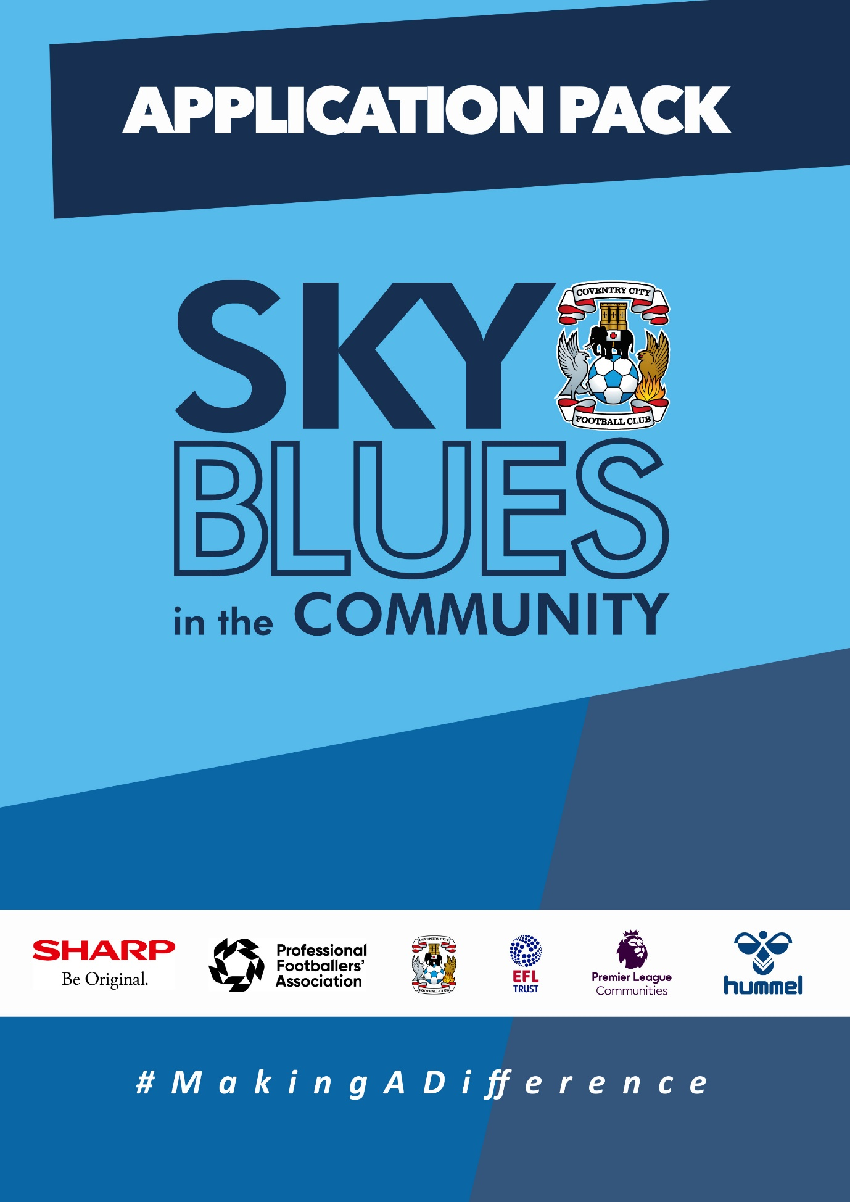

APPLICATION PACK

ABOUT US
Sky Blues in the Community is the official charity of Coventry City Football Club, proudly based at the Coventry Building Society Arena. Our mission is to harness the power of sport and physical activity, leveraging the unique influence and appeal of Coventry City Football Club to deliver impactful, high-quality community programs. Through strong partnerships and strategic alliances, we aim to empower individuals and communities across Coventry and Warwickshire.
Our work is driven by a commitment to social change and community empowerment. We provide inclusive and accessible opportunities to improve health and wellbeing, promote social inclusion, reduce crime, and enhance access to education and employment. Through these efforts, we aim to #MakeADifference across our city and county.
OUR STRATEGIC THEMES
Our work is structured around five core thematic areas, each with a distinct mission:
1. Health and Wellbeing
We are committed to addressing the health inequalities facing some of Coventry and Warwickshire’s most underrepresented communities. Through engaging, evidence-based programs, we support individuals to live healthier, happier lives, standing in partnership with organisations that share our vision for community wellbeing.
2. Education, Skills and Training
We aim to play a leading role in improving access to education, training, and employment opportunities. By inspiring confidence, providing practical tools and tailored support, we help individuals progress towards sustainable careers and lifelong learning.
3. Inclusion, Engagement and Participation
We are passionate about creating an active, inclusive, and cohesive community. Our programs provide opportunities for everyone—regardless of background, ability, or circumstance—to engage in physical activity in a welcoming, non-judgmental, and inspiring environment.
4. Sports Facilities and Community Assets
We are committed to enhancing the availability and quality of community spaces for sport and physical activity. By responding to the unique needs of our communities, we champion equitable access to inclusive, safe, and high-quality facilities that promote healthy lifestyles and social connection.
5. People and Infrastructure
Our people are our greatest asset. To sustain and grow our impact, we are investing in our team and our organisational infrastructure. We aim to ensure our workforce is reflective of our community and supported by continuous learning and development. We are committed to fostering a high-performing, inclusive, and purpose-driven working environment where everyone can thrive.

OUR VALUES
We expect all staff to embody our core values in everything they do:
- Community Focused
- Passionate
- Innovative
- Ambitious
- Inclusive

EQUALITY, DIVERSITY & INCLUSION
Sky Blues in the Community is committed to promoting equality, diversity, and inclusion across our workforce, services, and programs. We are dedicated to creating an environment where all individuals feel welcomed, respected, and empowered to reach their potential. We strive to embed inclusive practices throughout the organisation and challenge inequality wherever it arises.
SAFEGUARDING STATEMENT
We operate a person-centered approach to safeguarding. Where there are concerns about the welfare of a child or an adult at risk, we always act in their best interests. Sky Blues in the Community fully accepts its responsibility for safeguarding the wellbeing and safety of all individuals involved in our programs. All staff have a duty to create a safe, inclusive environment that protects children and adults at risk from harm. Safeguarding is everyone’s responsibility.

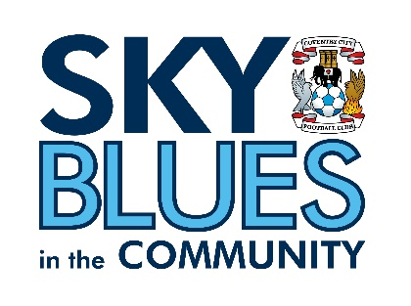

JOB DESCRIPTION
Job Title: | Data and Insight Coordinator | Reporting to: | Fundraising and Grants Manager
Salary: | £30,000 per annum | Contract Type: | Full time (37.5 hours per week)
Location: | Coventry Building Society  Judds Lane  Coventry  CV6 6GE | Days and hours of work: | Monday to Friday, core hours between 0800 – 2100 (37.5 hours a week)
Document created: | June 2026 | Reference number: | SBITC-DC

Purpose of the role:

The Data and Insight Coordinator will support Sky Blues in the Community to evidence the need for its programmes, measure the difference those programmes make, and use data and insight to improve delivery across Coventry and Warwickshire.

The post holder will coordinate the charity’s approach to data collection, monitoring, evaluation and impact reporting. They will help develop consistent systems, tools and reporting processes so that programme outcomes can be captured accurately, analysed effectively and communicated clearly to internal teams, trustees, funders, partners and other stakeholders.

The role will also support the development of new projects and funding applications by using local needs data, participant insight, stakeholder feedback and programme evidence. Working closely with managers, delivery staff and the marketing and communications team, the post holder will help ensure that Sky Blues in the Community can demonstrate its social value in a credible, evidence-based and engaging way.

Key relationships
The post holder will work closely with:
- Senior Management Team
- Project managers and coordinators
- Delivery staff across all programme areas
- Marketing and communications team
- Fundraising and grants colleagues
- Trustees, where required
- External partners, funders and stakeholders
- Participants and beneficiaries, where appropriate

Key responsibilities (but not completely exclusive to):

Data, insight and local needs analysis
- Collect, analyse and present data from beneficiaries, communities, partners and stakeholders to evidence local need and inform programme development.
- Carry out research into demographic, social, health, education, employment and community needs across Coventry and Warwickshire, using credible local, regional and national data sources.
- Support the development of new projects and funding applications by providing clear evidence of need, expected outcomes and relevant impact measures.
- Maintain awareness of sector developments, funder expectations and good practice in monitoring, evaluation and impact measurement.

Outcomes and impact framework
- Support the design, implementation and ongoing development of a consistent outcomes and impact framework across the charity.
- Work with managers to agree suitable programme outcomes, indicators, targets and methods of measurement.
- Develop practical tools to collect quantitative and qualitative evidence, including surveys, feedback forms, case study templates, outcome trackers and reporting templates.
- Support the use of theory of change models, logic models and evaluation frameworks to strengthen programme planning, delivery and reporting.
- Ensure impact measurement is proportionate, meaningful and aligned with the charity’s strategic priorities, funder requirements and community needs.

Data systems, quality and reporting
- Coordinate data collection processes across programmes, ensuring information is recorded consistently, accurately and in a timely manner.
- Review and improve current data and tracking systems, identifying opportunities to reduce duplication, improve reliability and make reporting more efficient.
- Support the development of automated or streamlined reporting processes where appropriate.
- Monitor data quality and work with staff to address gaps, inconsistencies or inaccuracies.
- Produce regular reports for coordinators, project managers, the Senior Management Team and trustees, showing progress against agreed targets, key trends, risks, learning points and areas for improvement.
- Prepare clear and accessible impact reports for funders, partners and wider stakeholders.

Communication of impact
- Work with the marketing and communications team to communicate programme impact through reports, case studies, participant stories, social value evidence and public-facing materials.
- Support colleagues to gather appropriate case studies and participant feedback, ensuring consent, confidentiality and safeguarding considerations are properly managed.
- Translate data and evaluation findings into clear messages that show the difference Sky Blues in the Community makes to individuals, families and communities.

Staff support and training
- Provide guidance and training to staff on data collection, monitoring, evaluation and impact measurement.
- Support staff to understand why accurate data matters and how it contributes to funding, service improvement, accountability and organisational growth.
- Promote a positive data culture where colleagues feel confident using evidence to review and improve programme delivery.

Governance, compliance and confidentiality
- Handle all data in line with UK GDPR, data protection requirements, organisational policies and confidentiality expectations.
- Ensure data collection methods are ethical, proportionate and appropriate for the participants and communities involved.
- Work with relevant colleagues to ensure that consent, privacy, safeguarding and information governance requirements are considered when collecting and using participant information.
- Maintain accurate records and support internal and external reporting requirements as needed.

General responsibilities
- Always Represent Sky Blues in the Community and Coventry City Football Club in a professional and positive manner.
- Demonstrate a commitment to safeguarding, equality, diversity and inclusion in all aspects of the role.
- Participate in training, supervision and Continuing Professional Development as required.
- Work flexibly and collaboratively to support the wider needs of the charity.
- Undertake any other reasonable duties appropriate to the role and level of responsibility.

This job description is not intended to be exhaustive. Duties may be reviewed from time to time to meet the needs of the organisation.

PERSON SPECIFICATION
Job Title: Data and Insight Coordinator
Essential criteria
- Demonstrable experience of collecting, managing, analysing and reporting data within an organisation, project or programme setting.
- Experience of using data to measure outputs, outcomes and impact, and to inform programme improvement or decision-making.
- Strong working knowledge of monitoring, evaluation and impact reporting, including the ability to develop or improve outcome-tracking processes.
- Advanced working knowledge of Microsoft Excel, with the ability to analyse data and present findings clearly through reports, dashboards, graphs or summaries.
- Strong research and analytical skills, including the ability to interpret local demographic, community and stakeholder data to evidence need and support programme development.
- Excellent written and verbal communication skills, with the ability to turn complex data into clear, practical insight for colleagues, senior leaders, trustees, funders and partners.
- Strong attention to detail and accuracy, with a sound understanding of confidentiality, data protection and responsible handling of personal or sensitive information.
- Proactive, organised and able to work independently and collaboratively, managing competing priorities and supporting colleagues to collect and use data effectively.
Desirable criteria
- A relevant qualification, or equivalent professional experience, in data, research, evaluation, impact measurement, information management, statistics, social sciences or a related field.
- Experience of working in the charity, sport, education, youth, health, community or social impact sector.
- Experience of using CRM systems, Salesforce, Power BI, dashboards or other data visualisation and reporting platforms.
- Experience of developing theory of change models, logic models, outcomes frameworks or evaluation plans.
- Experience of supporting funding applications, grant monitoring, commissioner reporting or impact reports for funders and external stakeholders.

APPLICATION INFORMATION
Do you believe that good data can help charities make better decisions, secure funding, and show the real difference they make?
At Sky Blues in the Community, the official charity of Coventry City Football Club, we use the power of football to connect communities, tackle inequality, support wellbeing, and create opportunities across Coventry and Warwickshire. Every day our programmes support children, families, older adults, young people at risk and people facing disadvantage.
We are recruiting a Data and Insight Coordinator to help us evidence the need for our work, measure the difference our programmes make, and communicate that impact clearly to funders, partners, trustees and the wider community.
This is a role for someone who is organised, analytical and confident working with data, but who also understands that behind every number is a person, a community need, or a story of change.
Why this role matters
Our programmes make a difference every day, but that difference must be properly evidenced.
Premier League Kicks keeps young people safe and engaged. Walking Football for Parkinson’s gives people with neurological conditions a place to stay active and connected. Premier League Primary Stars and Inspires reach children and young people across our region. Our health, inclusion, sport and education programmes all respond to real needs in the communities we serve.
To continue growing that work, we need accurate data, strong evidence, meaningful insight and clear reporting. This role will help us understand what is needed, what is working, where we can improve, and how we can demonstrate our impact with confidence.
The Data and Impact Coordinator will support the development of consistent systems across the charity, helping colleagues collect the right information, measure outcomes properly and use evidence to improve programme delivery.
What makes this opportunity unique
You will be based at the Coventry Building Society Arena, home of Coventry City Football Club, and will work across a charity with a broad and varied programme offer across Coventry and Warwickshire.
The role gives you the opportunity to work across all areas of our delivery, including sport, health, inclusion, education, employment and community programmes. You will see first-hand how data and insight can shape programme design, strengthen funding applications, improve reporting and help tell the story of the charity’s work.
This is a practical, hands-on role with real organisational influence. You will not simply be producing spreadsheets or reports in isolation. You will work with programme managers, delivery staff, the Senior Management Team, trustees, fundraisers and marketing colleagues to build a more consistent and evidence-led approach to impact across SBitC.
What you will do
Your work will support how SBitC understands, measures and communicates its impact. The role focuses on four main areas:
Data, insight and community need
- You will collect and analyse data from programmes, beneficiaries, partners and wider community sources to help us understand local need across Coventry and Warwickshire.
- You will carry out research into demographic trends, local inequalities, health and wellbeing needs, education outcomes, community challenges and other relevant data. This insight will help shape new projects, inform funding applications and ensure our programmes remain responsive to the communities we serve.
Monitoring, evaluation and outcomes
- You will help develop and implement a consistent outcomes framework across the charity, making sure our programmes are measuring the right things in the right way.
- You will support colleagues to define outcomes, track progress, collect evidence and understand what the data is telling us. This will include developing tools such as surveys, feedback forms, outcome trackers, case study templates and reporting processes.
- You will also support the use of theory of change models, logic models and evaluation frameworks where they help strengthen programme planning and impact measurement.
Data systems, reporting and improvement
- You will support the charity to improve the way it collects, stores, manages and reports data. This will include reviewing current systems, identifying gaps or inconsistencies, improving processes and helping to make reporting more efficient.
- You will produce regular reports for coordinators, project managers, the Senior Management Team and trustees, summarising progress against agreed targets, key outcomes, trends, risks and learning points.
- You will help ensure that our data is accurate, reliable, accessible and handled responsibly, including in line with confidentiality and data protection requirements.
Communicating impact
- You will work closely with the marketing and communications team to help turn data and evidence into clear, meaningful impact stories. This may include supporting impact reports, case studies, funder updates, stakeholder reports and public-facing materials that show how SBitC is making a difference. Your role will help to ensure that our impact is communicated in a way that is credible, evidence-based and accessible.
- You will also support and train staff so that colleagues across the organisation understand how to collect data well, why it matters, and how it contributes to funding, improvement and long-term sustainability.

What we are looking for
We are looking for someone with experience of collecting, managing, analysing and presenting data in an organisational, project or programme setting. You will be confident using Excel and reporting tools, able to work accurately with data, and capable of turning information into clear insight.
You will understand monitoring, evaluation and impact measurement, with the ability to develop practical systems for tracking outcomes and programme effectiveness. Experience of working with dashboards, CRM systems, data visualisation tools, theory of change models or logic frameworks would be an advantage.
Just as importantly, you will be able to work well with people. This role will involve supporting colleagues across different teams, explaining data in a clear and practical way, and helping staff feel confident with monitoring and evaluation processes.
Experience in the charity, sport, education, youth, health, community or social impact sector would be helpful, but what matters most is that you are organised, accurate, curious, proactive and committed to using data to improve the quality and impact of community programmes.
A commitment to safeguarding children and adults at risk is essential, as is a genuine belief in the value of community-based work.
Why you will enjoy working here
This role offers the opportunity to make a visible contribution to a charity that is closely connected to the communities it serves.
You will be part of a small, committed team working under the banner of Coventry City Football Club, with access to a wide range of programmes and community stories. Your work will help colleagues understand what is working, improve what we deliver, and evidence the value of our programmes to funders, partners and trustees.
The experience you gain here will strengthen your professional profile across data, impact, evaluation, charity operations and community sport. You will help build systems that support the charity’s future growth and ensure that SBitC can continue demonstrating the difference it makes across Coventry and Warwickshire.
How to Apply
To apply, please submit either:
- A CV and covering letter or
- A completed application form
Your application should clearly demonstrate how you meet the criteria outlined in the person specification.
Please send your application to: David Busst at recruitment@sbitc.org.uk
Please note: You only need to submit either a CV and covering letter or a completed application form, not both.
Closing date for applications: 20th of July 2026
Please note that we may close the application process early if we receive a high number of applications, so early applications are encouraged.
If you require the application form in an alternative format, or if you would like to apply using a different method due to a disability or accessibility need, please contact us via 024 7678 6349 and we will be happy to discuss reasonable adjustments.
Safer Recruitment and Pre-Employment Checks
At Sky Blues in the Community, safeguarding is central to everything we do. We are committed to creating a safe and supportive environment for all staff, volunteers, and participants.
This role may involve working with children or adults at risk, and as part of our safer recruitment process, any offer of employment will be subject to:
- Two satisfactory references
- An enhanced Disclosure and Barring Service (DBS) check
- Confirmation of your identity and right to work in the UK

All staff are expected to follow our Safeguarding Policies and complete relevant training as part of their induction and ongoing professional development.
Diversity and Inclusion
Sky Blues in the Community is an equal opportunities employer. We welcome applications from all sections of the community and particularly encourage applications from individuals who are underrepresented in the sport and charity sectors. Appointments are made strictly on merit.
We are committed to providing an inclusive recruitment process. If you require any adjustments to complete your application or to attend an interview, please let us know.
We may collect anonymised equalities data from applicants for monitoring purposes only. This data will not form any part of the recruitment decision-making process.
Privacy Notice
Sky Blues in the Community is committed to handling your personal information responsibly and transparently. We comply with the UK General Data Protection Regulation (UK GDPR) and the Data Protection Act 2018 to ensure the privacy and security of your data.
Information provided during the recruitment process will be stored securely and retained for a period of six months after the closing date of the vacancy, unless a longer period is required by law or you consent to us retaining your details for future opportunities.
To request a copy of our privacy notice or exercise your data rights, please contact: sbitc@sbitc.org.uk.

