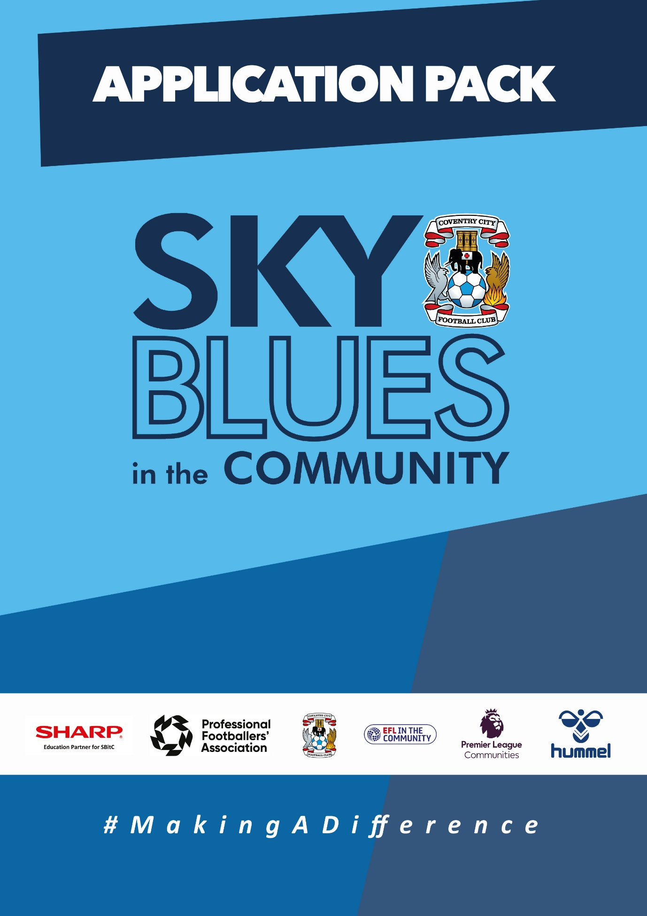

APPLICATION PACK
ABOUT US
Sky Blues in the Community is the official charity of Coventry City Football Club, proudly based at the Coventry Building Society Arena. Our mission is to harness the power of sport and physical activity, leveraging the unique influence and appeal of Coventry City Football Club to deliver impactful, high-quality community programs. Through strong partnerships and strategic alliances, we aim to empower individuals and communities across Coventry and Warwickshire.
Our work is driven by a commitment to social change and community empowerment. We provide inclusive and accessible opportunities to improve health and wellbeing, promote social inclusion, reduce crime, and enhance access to education and employment. Through these efforts, we aim to #MakeADifference across our city and county.
OUR STRATEGIC THEMES
Our work is structured around five core thematic areas, each with a distinct mission:
1. Health and Wellbeing
We are committed to addressing the health inequalities facing some of Coventry and Warwickshire’s most underrepresented communities. Through engaging, evidence-based programs, we support individuals to live healthier, happier lives, standing in partnership with organisations that share our vision for community wellbeing.
2. Education, Skills and Training
We aim to play a leading role in improving access to education, training, and employment opportunities. By inspiring confidence, providing practical tools and tailored support, we help individuals progress towards sustainable careers and lifelong learning.
3. Inclusion, Engagement and Participation
We are passionate about creating an active, inclusive, and cohesive community. Our programs provide opportunities for everyone—regardless of background, ability, or circumstance—to engage in physical activity in a welcoming, non-judgmental, and inspiring environment.
4. Sports Facilities and Community Assets
We are committed to enhancing the availability and quality of community spaces for sport and physical activity. By responding to the unique needs of our communities, we champion equitable access to inclusive, safe, and high-quality facilities that promote healthy lifestyles and social connection.
5. People and Infrastructure
Our people are our greatest asset. To sustain and grow our impact, we are investing in our team and our organisational infrastructure. We aim to ensure our workforce is reflective of our community and supported by continuous learning and development. We are committed to fostering a high-performing, inclusive, and purpose-driven working environment where everyone can thrive.

OUR VALUES
We expect all staff to embody our core values in everything they do:
- Community Focused
- Passionate
- Innovative
- Ambitious
- Inclusive

EQUALITY, DIVERSITY & INCLUSION
Sky Blues in the Community is committed to promoting equality, diversity, and inclusion across our workforce, services, and programs. We are dedicated to creating an environment where all individuals feel welcomed, respected, and empowered to reach their potential. We strive to embed inclusive practices throughout the organisation and challenge inequality wherever it arises.
SAFEGUARDING STATEMENT
We operate a person-centered approach to safeguarding. Where there are concerns about the welfare of a child or an adult at risk, we act in their best interests at all times. Sky Blues in the Community fully accepts its responsibility for safeguarding the wellbeing and safety of all individuals involved in our programs. All staff have a duty to create a safe, inclusive environment that protects children and adults at risk from harm. Safeguarding is everyone’s responsibility.

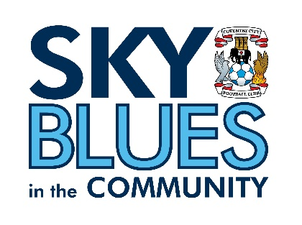

JOB DESCRIPTION
Job Title: | SBITC-Sports and Participation Coach | Reporting to: | SBITC Manager
Salary: | £25,000 per annum | Contract Type: | Full time (37.5 hours per week)
Location: | Across Coventry and Warwickshire | Days and hours of work: | Full time  The standard working week will include either a Saturday or Sunday as part of your regular schedule. Specific days and hours will be confirmed upon hiring.
Document created: | April 2025 | Reference: | SBITC-SPC

Purpose of the role:

The post holder will plan, deliver, and evaluate sport and physical activity sessions to children, young people and adults across a variety of programmes from the four key themes of the organisation (sport, health, inclusion and education). The post holder will ensure all sessions are delivered to the highest possible standard by following the Sky Blues in the Community quality assurance framework.
Key responsibilities (but not completely exclusive to):

- Plan, deliver and evaluate a variety of age-appropriate sport and physical activity, and wellbeing coaching sessions to meet the needs of groups and individuals in accordance with the Sky Blues in the Community programme.
- Work in diverse settings, such as community settings, youth clubs, leisure centres, public parks and open spaces, schools and colleges
- Undertake administrative tasks related to the sessions that you are responsible for including updating registers, consent forms, risk assessments, incident and accident forms, writing case studies and social media posts that demonstrate impact of projects, and recording any outcomes and accreditations achieved by participants using relevant monitoring and evaluation systems.
- Work with individuals and/or groups from a range of backgrounds, abilities, and age ranges
- Be responsible for the correct use of and safe keeping of sport and physical activity equipment.
- Ensure that the safety of facilities is checked before and during use for practical participation.
- Build and support positive working partnerships with existing/new key partners to receive continued funding for delivery of programmes.
- Maintain high standards of professional behaviour towards colleagues, young people, and adults with whom we engage and the wider public when working for and wearing Sky Blues in the Community uniform.
- Maintain an up-to-date knowledge of, and adhere to, Sky Blues in the Community policies and procedures, including those relating to Safeguarding, Health and Safety and emergency procedures, including those of venues where you may be based.
- Work with Managers/Coordinators/Officers to support design and development of activities and programmes.
- Work as a team, effectively supervising, mentoring, and directing colleagues (coaches and volunteers) where appropriate.
- Develop professional and supportive relationships with all young people engaged in the session.
- Undertake regular professional development days as set by Sky Blue sin the Community to continue own personal development.
- Carry a fully stocked first aid kit when coaching.
- Undertake other duties as required to ensure efficient delivery of Sky Blues in the Community sessions.
- To undertake relevant training courses as requested by Sky Blues in the Community.
- Be self-motivated, committed, and reliable.
- Always represent Sky Blues in the Community and Coventry City Football Club in a professional manner.
- To work and deliver on Player Development programme

Safeguarding and Organisational Values
- Uphold and actively promote SBitC’s commitment to safeguarding children and adults at risk in all funding activity, ensuring all applications and funder-facing communications reflect organisational policies and values.
- Champion SBitC’s commitment to equality, diversity and inclusion in the development of bids and in the relationships maintained with funders.
- Complete all required safeguarding training and ensure it is kept current.

PERSON SPECIFICATION
Job Title: Sport and Participation Coach
Person Specification
Attributes | Essential | Desirable | Method of assessment
Qualifications and Experience | Experience of planning, delivering and evaluating sport and physical activity sessions within a community, school and club environment.  Up to date, relevant certifications in Emergency Aid and safeguarding (needs to be completed before start date). | A sports coaching or development degree (or equivalent).  FA Level 2 in Coaching Football (or any NGB sport).  Level 2 Youth Worker Award.  Level 3 NVQ Diploma in Supporting the Delivery of Physical Education and School Sport (QCF)  Experience of writing, developing and delivering educational lessons, workshops and/or session plans.  Experience of data collection for monitoring and evaluation purposes. | Application form and interview
Skills, abilities, and knowledge | Excellent planning, organisational & time-management skills.  Strong interpersonal skills for communicating with a range of people and partners.  An understanding of and a commitment to equal opportunities both in the workplace and the wider community.  Commitment to Safeguarding children and young people. | Knowledge of the National Curriculum PE and Education.  Relevant knowledge of sport and community development (particularly in the football industry).  Comprehensive understanding of the importance of providing a high-quality experience for participants and customers.  IT skills including Microsoft Excel, Word, and PowerPoint | Application form and interview
Personal qualities | Full driving licence and access to transport.  Positive ‘Can do’ attitude.  Friendly and outgoing  Authoritative.  Team player.  Passionate about Making a difference through the power of sport and football. |  | Application form and interview

Our values at SBiTC
At SBiTC, our values guide everything we do. We expect all applicants and colleagues to share and demonstrate these values in their daily practice:
- Acting with integrity, professionalism and confidentiality at all times.
- Remaining resilient, composed and solution-focused when faced with challenging behaviours.
- Demonstrating a positive, approachable manner and a genuine “can do” attitude.
- Being passionate about inclusion and committed to making a meaningful difference in young people’s lives.
- Showing enthusiasm, energy and adaptability, even under pressure.
- Upholding our commitment to safeguarding, equality, diversity and inclusion in every aspect of our work.

APPLICATION INFORMATION
Do you want to spend your working week doing something that actually matters?
At Sky Blues in the Community, the official charity of Coventry City Football Club, we use the power of football to connect communities, improve wellbeing, and create opportunities for people of all ages across Coventry and Warwickshire. Our coaches are the people who make that happen. Every session, every school visit, every community programme starts with someone who shows up ready to deliver.
We are recruiting a Sports and Participation Coach to plan, deliver and evaluate sport and physical activity sessions across our programmes. If you are a confident, energetic coach who thrives working with diverse groups and wants a role where no two weeks look the same, this is it.
What you will be doing
You will plan and deliver sport and physical activity sessions to children, young people and adults across a wide range of settings, from schools and youth clubs to community centres, parks and leisure facilities. You will work across all four of SBitC's programme themes: sport, health, inclusion and education, adapting your delivery to meet the needs of the groups and individuals in front of you.
Alongside coaching, you will keep accurate records, update registers and outcome systems, complete risk assessments, and contribute to the monitoring and evaluation activity that demonstrates the impact of what we do. You will build positive working relationships with partners and colleagues, mentor volunteers and fellow coaches where appropriate, and always represent SBitC and Coventry City Football Club with professionalism.
What we are looking for
You will have experience planning, delivering and evaluating sport and physical activity sessions in community, school or club environments, and you will hold current Emergency Aid and safeguarding qualifications before your start date. A full driving licence and access to transport are essential.
Beyond the qualifications, we are looking for someone with a positive, can-do attitude, strong interpersonal skills, and a genuine passion for making a difference through sport. A sports coaching degree, FA Level 2 or equivalent NGB coaching award would be an advantage, as would experience in monitoring and evaluation or educational delivery.
A commitment to safeguarding children and adults at risk, and to equality, diversity and inclusion, is essential.

The role
This is a full-time role of 37.5 hours per week. Your working week will include either a Saturday or Sunday as part of your regular schedule, with specific days confirmed on appointment. You will be based across Coventry and Warwickshire.
Why join us
You will be part of a team that uses one of the most recognisable names in the city to open doors and build trust in communities where it counts. The work is varied, the impact is visible, and the development opportunities are real. If you want a coaching role with genuine purpose behind it, we would like to hear from you.
How to Apply
To apply, please submit either:
- A CV and covering letter or
- A completed application form
Your application should clearly demonstrate how you meet the criteria outlined in the person specification.
Please send your application to us at: recruitment@sbitc.org.uk
Please note: You only need to submit either a CV and covering letter or a completed application form, not both.
Closing date for applications: 24th of May 2026
Please note that we may close the application process early if we receive a high number of applications, so early applications are encouraged.
If you require the application form in an alternative format, or if you would like to apply using a different method due to a disability or accessibility need, please contact us via 024 7678 6349 and we will be happy to discuss reasonable adjustments.
Safer Recruitment and Pre-Employment Checks
At Sky Blues in the Community, safeguarding is central to everything we do. We are committed to creating a safe and supportive environment for all staff, volunteers, and participants.
This role may involve working with children or adults at risk, and as part of our safer recruitment process, any offer of employment will be subject to:
- Two satisfactory references
- An enhanced Disclosure and Barring Service (DBS) check
- Confirmation of your identity and right to work in the UK

All staff are expected to follow our Safeguarding Policies and complete relevant training as part of their induction and ongoing professional development.

Diversity and Inclusion
Sky Blues in the Community is an equal opportunities employer. We welcome applications from all sections of the community and particularly encourage applications from individuals who are underrepresented in the sport and charity sectors. Appointments are made strictly on merit.
We are committed to providing an inclusive recruitment process. If you require any adjustments to complete your application or to attend an interview, please let us know.
We may collect anonymised equalities data from applicants for monitoring purposes only. This data will not form any part of the recruitment decision-making process.
Privacy Notice
Sky Blues in the Community is committed to handling your personal information responsibly and transparently. We comply with the UK General Data Protection Regulation (UK GDPR) and the Data Protection Act 2018 to ensure the privacy and security of your data.
Information provided during the recruitment process will be stored securely and retained for a period of six months after the closing date of the vacancy, unless a longer period is required by law or you consent to us retaining your details for future opportunities.
To request a copy of our privacy notice or exercise your data rights, please contact: sbitc@sbitc.org.uk.

