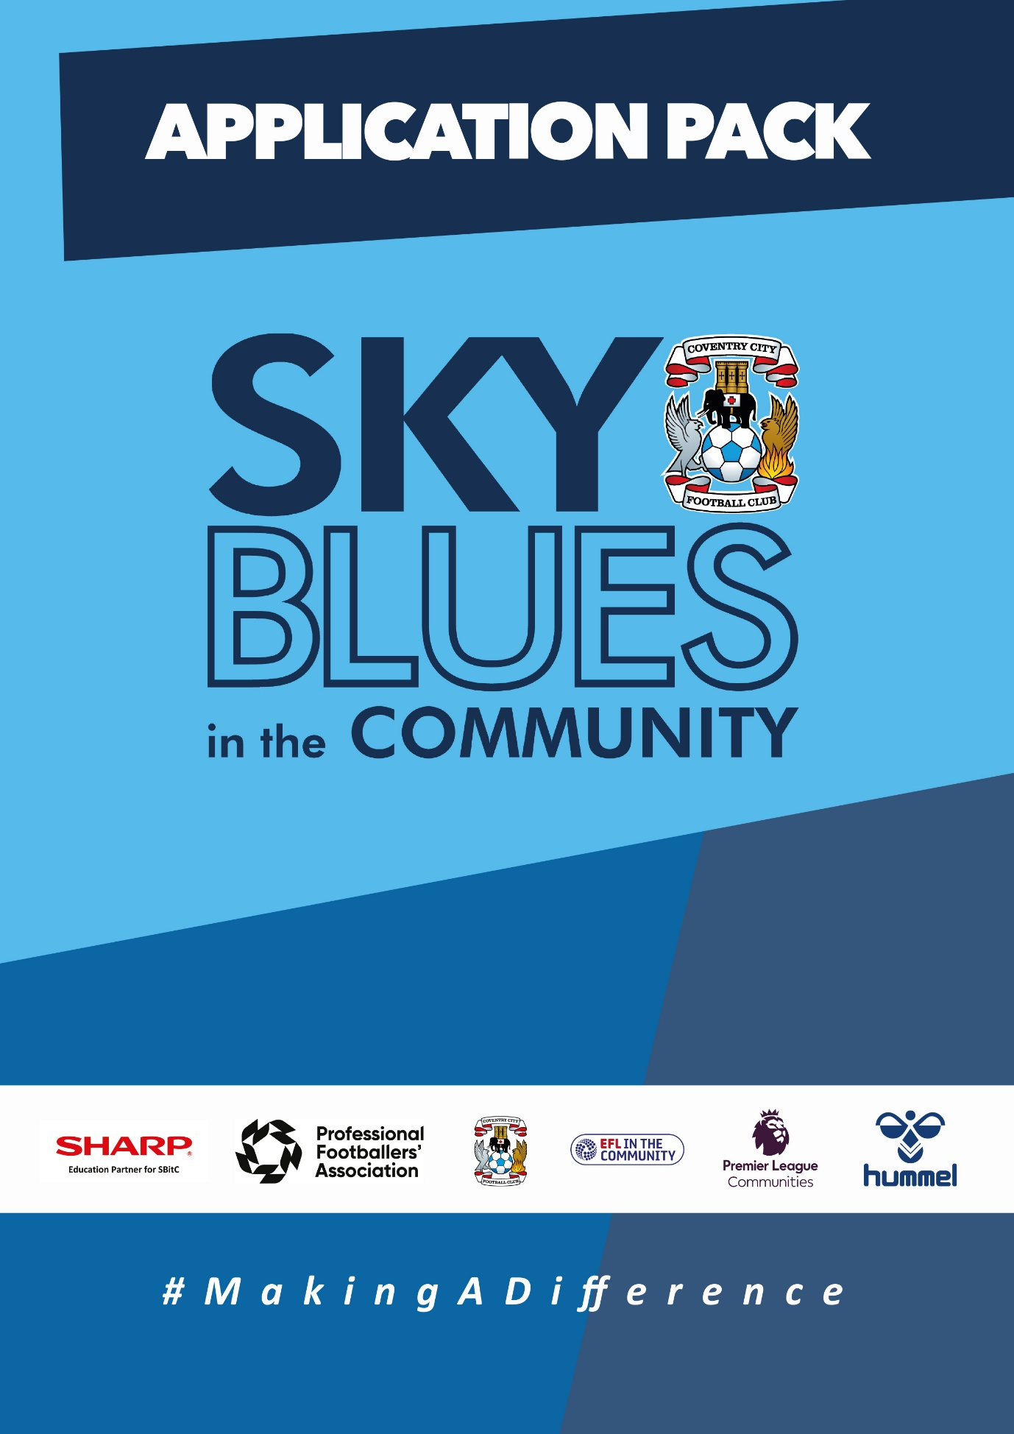

APPLICATION PACK
ABOUT US
Sky Blues in the Community is the official charity of Coventry City Football Club, proudly based at the Coventry Building Society Arena. Our mission is to harness the power of sport and physical activity, leveraging the unique influence and appeal of Coventry City Football Club to deliver impactful, high-quality community programs. Through strong partnerships and strategic alliances, we aim to empower individuals and communities across Coventry and Warwickshire.
Our work is driven by a commitment to social change and community empowerment. We provide inclusive and accessible opportunities to improve health and wellbeing, promote social inclusion, reduce crime, and enhance access to education and employment. Through these efforts, we aim to #MakeADifference across our city and county.
OUR STRATEGIC THEMES
Our work is structured around five core thematic areas, each with a distinct mission:
1. Health and Wellbeing
We are committed to addressing the health inequalities facing some of Coventry and Warwickshire’s most underrepresented communities. Through engaging, evidence-based programs, we support individuals to live healthier, happier lives, standing in partnership with organisations that share our vision for community wellbeing.
2. Education, Skills and Training
We aim to play a leading role in improving access to education, training, and employment opportunities. By inspiring confidence, providing practical tools and tailored support, we help individuals progress towards sustainable careers and lifelong learning.
3. Inclusion, Engagement and Participation
We are passionate about creating an active, inclusive, and cohesive community. Our programs provide opportunities for everyone—regardless of background, ability, or circumstance—to engage in physical activity in a welcoming, non-judgmental, and inspiring environment.
4. Sports Facilities and Community Assets
We are committed to enhancing the availability and quality of community spaces for sport and physical activity. By responding to the unique needs of our communities, we champion equitable access to inclusive, safe, and high-quality facilities that promote healthy lifestyles and social connection.
5. People and Infrastructure
Our people are our greatest asset. To sustain and grow our impact, we are investing in our team and our organisational infrastructure. We aim to ensure our workforce is reflective of our community and supported by continuous learning and development. We are committed to fostering a high-performing, inclusive, and purpose-driven working environment where everyone can thrive.

OUR VALUES
We expect all staff to embody our core values in everything they do:
- Community Focused
- Passionate
- Innovative
- Ambitious
- Inclusive

EQUALITY, DIVERSITY & INCLUSION
Sky Blues in the Community is committed to promoting equality, diversity, and inclusion across our workforce, services, and programs. We are dedicated to creating an environment where all individuals feel welcomed, respected, and empowered to reach their potential. We strive to embed inclusive practices throughout the organisation and challenge inequality wherever it arises.
SAFEGUARDING STATEMENT
We operate a person-centered approach to safeguarding. Where there are concerns about the welfare of a child or an adult at risk, we act in their best interests at all times. Sky Blues in the Community fully accepts its responsibility for safeguarding the wellbeing and safety of all individuals involved in our programs. All staff have a duty to create a safe, inclusive environment that protects children and adults at risk from harm. Safeguarding is everyone’s responsibility.

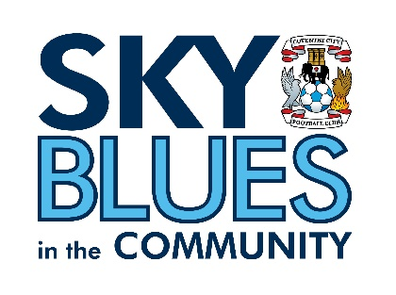

JOB DESCRIPTION
Job Title: | SBITC-Project Manager, Sky Blues Talk | Reporting to: | SBITC-Operations Manager
Salary: | £30,000 per annum | Contract Type: | Full time (37.5 hours per week)
Location: | SBITC Offices, CBS Arena, Coventry | Days and hours of work: | This is a full-time role of 37.5 hours per week. Core days are Monday to Friday, with flexibility required to work on Saturdays to support matchday delivery.
Document created: | April 2025 | Reference: | SBITC-PMH

Purpose of the role:

The Projects Manager will lead the strategic planning, coordination, and delivery of a portfolio of community-based health and wellbeing programmes. This includes day-to-day management of SBitC’s Sky Blues Talk Programme, and partnership delivery aligned with it.
The post holder will be responsible for line managing delivery staff working on this programme, and for ensuring that all projects, events and sessions are planned and delivered to the highest standards. This includes responsibility for achieving agreed key performance indicators and grant funding obligations, and for sustaining and growing programmes through effective partnership management, monitoring, evaluation and impact reporting.
The role combines strategic project management with hands-on operational management.
Key responsibilities (but not completely exclusive to):

Programme Leadership and Delivery
- Lead the planning, coordination, and delivery of the Sky Blues Talk Programme.
- Develop structured delivery plans, ensuring programmes are phased, scalable, and tailored to community need.
- Oversee both group-based and one-to-one interventions, maintaining a balance of physical activity, social connection, and mental wellbeing support.
- Assess and support individuals on programme who are experiencing mental health difficulties, and design and deliver tailored interventions accordingly.
- Make accurate assessments of risk to participants and others, including identifying support needs and escalating where appropriate.
- Ensure programme is delivered in accessible, community-based settings including community centres, parks, and schools – according to project agreement.
- Support the creation and delivery of future mental health projects, which may include work in primary schools.
People Management
- Line manage and support programme staff directly supporting Sky Blues Talk programme, including conducting regular one-to-ones and appraisals in line with internal processes.
- Ensure staff working on the Sky Blues Talk programme are trained in safeguarding, mental health awareness, and best practice delivery.
- Support volunteers and develop volunteer pathways that enhance programme sustainability and community ownership.
- Foster a culture of continuous improvement, collaboration, and high performance across the team.
Community Engagement and Co-Design
- Embed a community-led approach by involving participants in shaping programme content, delivery locations, and activity types.
- Build trusted relationships with participants, supporting engagement, retention, and progression.
- Promote physical and mental wellbeing and social inclusion across all aspects of delivery.
Partnership and Stakeholder Management
- Develop and maintain strong relationships with Sky Blues Talk partners, local authorities, schools, community organisations, and voluntary sector groups.
- Act as the primary point of contact for programme stakeholders, ensuring effective communication and collaboration.
- Promote SBitC’s brand and ethos professionally, seeking to enhance the organisation’s reputation as a trusted and high-quality provider.
Monitoring, Evaluation and Financial Management
- Oversee data collection, monitoring, and evaluation processes to measure programme impact on mental and physical wellbeing, using validated pre and post measures.
- Keep accurate records of all individuals attending sessions and upload data to monitoring and evaluation systems to demonstrate impact.
- Produce high-quality reports to demonstrate outcomes, support funding applications, and inform commissioning opportunities.
- Monitor and manage project financial budgets, ensuring expenditure remains on target across the portfolio.
Safeguarding, Risk and Compliance
- Ensure Sky Blues Talk Programme is delivered in line with SBitC safeguarding policies and procedures.
- Oversee risk assessments, including participant wellbeing and safety.
- Maintain compliance with organisational policies and relevant legislation, including data protection obligations under the GDPR and Data Protection Act 2018.
- Promote equality, diversity, and inclusion across all aspects of delivery and team management.
- Attend relevant CPD, conferences, and events in line with professional development objectives.
- Undertake any other duties reasonably required within the scope of the role.

PERSON SPECIFICATION
Job Title: Project Manager – Sky Blues Talk

Essential
- Proven experience managing projects within health, sport, or community settings.
- Experience delivering mental health and/or physical activity programmes, including both group-based and one-to-one interventions.
- Experience of providing one-to-one support and interventions for adults and/or children and young people experiencing mental health conditions.
- Experience line managing and developing a team, including conducting one-to-ones and appraisals.
- Mental Health First Aid qualification.
- Up-to-date safeguarding and first aid qualifications.
- Strong knowledge of health systems, mental health services, and relevant agencies.
- Experience managing partnerships with NHS, Primary Care, or community stakeholders.
- Experience of monitoring, evaluation, and impact reporting, including use of pre and post outcome measures.
- Experience managing project budgets and following financial processes and procedures.
- Experience working in a setting with agreed targets for demonstrating clinical or programme outcomes.
- Strong organisational and time management skills, with the ability to manage multiple programmes simultaneously and prioritise under pressure.
- Excellent verbal and written communication skills.
- Ability to develop effective therapeutic relationships with individuals.
- Strong leadership skills with the ability to motivate, support and develop a team.
- Competent user of MS Office suite; confident in the use of data management and monitoring systems.
- Accurate, diligent, and conscientious in record-keeping and reporting.
- Commitment to equality, diversity, and inclusion.
- Understanding of safeguarding and risk management in community delivery.
- Willingness to work flexibly, including evenings, weekends, and occasional public holidays.
- Commitment to safeguarding children and adults at risk, and to equality, diversity and inclusion.

Desirable
- Degree in psychology, counselling, mental health, or a relevant clinical discipline, or equivalent demonstrable experience.
- Awareness and understanding of social prescribing.
- Project management qualification (e.g. PRINCE2 or equivalent).
- Training in other psychological therapies (e.g. CBT-based approaches).
- Experience of delivering CBT-based group or individual interventions.
- Experience of community engagement and co-design approaches.
- Knowledge of dementia support programmes or older adult provision.

Our values at SBiTC
At SBiTC, our values guide everything we do. We expect all applicants and colleagues to share and demonstrate these values in their daily practice:
- Acting with integrity, professionalism and confidentiality at all times.
- Remaining resilient, composed and solution-focused when faced with challenging behaviours.
- Demonstrating a positive, approachable manner and a genuine “can do” attitude.
- Being passionate about inclusion and committed to making a meaningful difference in young people’s lives.
- Showing enthusiasm, energy and adaptability, even under pressure.
- Upholding our commitment to safeguarding, equality, diversity and inclusion in every aspect of our work.

APPLICATION INFORMATION
Do you believe that sport has the power to change lives, and that the right support at the right time is what makes that possible?
At Sky Blues in the Community, the official charity of Coventry City Football Club, we use the power of football to connect communities, tackle inequality, support wellbeing, and create opportunities across Coventry and Warwickshire. Our programmes reach children, families, older adults, young people at risk, and people facing mental health challenges every day. This role is what makes those programmes work.
We are recruiting a Project Manager to lead the delivery of our Sky Blues Talk programme. If you are passionate about mental health and wellbeing, experienced in working with people facing genuine difficulties, and skilled at bringing together teams, partners and communities to create lasting impact, this is a role where your work will be felt directly.
Why this role matters
Sky Blues Talk exists to improve the mental health and wellbeing of people across Coventry and Warwickshire through sport and physical activity. The programme combines group-based delivery with one-to-one support, reaches participants in community centres, parks and schools, and works alongside NHS, primary care and voluntary sector partners to connect people with the right help.
The Project Manager leads all of it. You will plan and coordinate delivery, manage and develop a team of programme staff, hold the funder relationships and compliance obligations, and ensure every participant receives a safe, high-quality experience. This is a hands-on leadership role that combines strategic oversight with day-to-day operational management.
What makes this opportunity unique
You will be based at the Coventry Building Society Arena, home of Coventry City Football Club, working under the banner of an organisation whose reach into communities across Coventry and Warwickshire is genuinely distinctive. The Sky Blues name opens doors. The programmes behind it make a difference.
You will work with a wide range of partners across health, education and the voluntary sector, engaging participants in shaping what the programme looks like and how it is delivered. You will have the scope to support the development of future mental health projects, including potential work in primary schools, and to build a team culture defined by high standards and continuous improvement.
What you will do
Your work will span four main areas.
Programme leadership and delivery: leading the planning, coordination and delivery of Sky Blues Talk, including both group-based and one-to-one interventions. You will assess and support individuals experiencing mental health difficulties, design tailored delivery plans, manage risk, and ensure the programme is delivered to the highest standard across accessible, community-based settings.
People management: line managing programme staff, conducting regular one-to-ones and appraisals, supporting volunteers, and building a team committed to quality, safeguarding, and participant welfare.
Partnership and stakeholder management: acting as the primary contact for Sky Blues Talk partners, local authorities, schools, community organisations, and voluntary sector groups, maintaining the relationships that sustain and grow the programme.
Monitoring, evaluation and financial management: overseeing data collection and impact reporting using validated outcome measures, producing reports that demonstrate programme impact and support future funding, and managing project budgets across the portfolio.
Please note that this is a full-time role of 37.5 hours per week. Core days are Monday to Friday, with flexibility required to work on Saturdays to support matchday delivery.

What we are looking for
We are looking for someone with proven experience managing projects in health, sport, or community settings, and direct experience delivering mental health programmes including one-to-one support for adults or young people. You will hold a Mental Health First Aid qualification and be up to date on safeguarding and first aid. Experience managing partnerships with NHS or primary care stakeholders, and confidence working to agreed clinical or programme outcome targets, are essential.
Strong leadership skills, excellent communication, and a diligent approach to record-keeping and reporting will all be important in this role. A degree in psychology, counselling, mental health or a related discipline is desirable, as is awareness of social prescribing and experience of CBT-based approaches.
A genuine commitment to safeguarding children and adults at risk, and to equality, diversity and inclusion, is essential.
Why you will enjoy working here
This role offers meaningful, visible work in a small and dedicated team, operating under the banner of a professional football club that gives our charity a reach and credibility that very few community organisations can match. You will build lasting relationships with NHS, primary care, and community partners, and have real scope to shape how Sky Blues Talk develops.
The experience you gain here will strengthen your professional profile across community health, mental health and sport for development sectors, and you will be making a direct, measurable difference to people's lives across Coventry and Warwickshire.
How to Apply
To apply, please submit either:
- A CV and covering letter or
- A completed application form
Your application should clearly demonstrate how you meet the criteria outlined in the person specification.
Please send your application to: David Busst at recruitment@sbitc.org.uk
Please note: You only need to submit either a CV and covering letter or a completed application form, not both.
Closing date for applications: 24th of May 2026
Please note that we may close the application process early if we receive a high number of applications, so early applications are encouraged.
If you require the application form in an alternative format, or if you would like to apply using a different method due to a disability or accessibility need, please contact us via 024 7678 6349 and we will be happy to discuss reasonable adjustments.
Safer Recruitment and Pre-Employment Checks
At Sky Blues in the Community, safeguarding is central to everything we do. We are committed to creating a safe and supportive environment for all staff, volunteers, and participants.
This role may involve working with children or adults at risk, and as part of our safer recruitment process, any offer of employment will be subject to:
- Two satisfactory references
- An enhanced Disclosure and Barring Service (DBS) check
- Confirmation of your identity and right to work in the UK

All staff are expected to follow our Safeguarding Policies and complete relevant training as part of their induction and ongoing professional development.
Diversity and Inclusion
Sky Blues in the Community is an equal opportunities employer. We welcome applications from all sections of the community and particularly encourage applications from individuals who are underrepresented in the sport and charity sectors. Appointments are made strictly on merit.
We are committed to providing an inclusive recruitment process. If you require any adjustments to complete your application or to attend an interview, please let us know.
We may collect anonymised equalities data from applicants for monitoring purposes only. This data will not form any part of the recruitment decision-making process.
Privacy Notice
Sky Blues in the Community is committed to handling your personal information responsibly and transparently. We comply with the UK General Data Protection Regulation (UK GDPR) and the Data Protection Act 2018 to ensure the privacy and security of your data.
Information provided during the recruitment process will be stored securely and retained for a period of six months after the closing date of the vacancy, unless a longer period is required by law or you consent to us retaining your details for future opportunities.
To request a copy of our privacy notice or exercise your data rights, please contact: sbitc@sbitc.org.uk.

