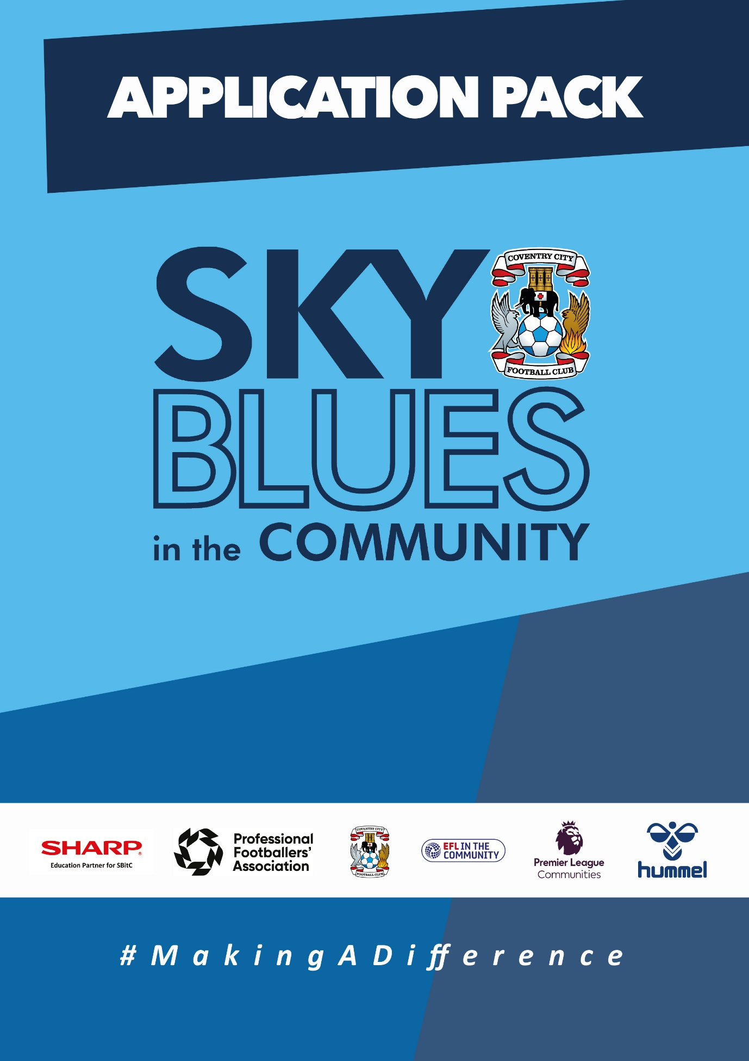

APPLICATION PACK
ABOUT US
Sky Blues in the Community is the official charity of Coventry City Football Club, proudly based at the Coventry Building Society Arena. Our mission is to harness the power of sport and physical activity, leveraging the unique influence and appeal of Coventry City Football Club to deliver impactful, high-quality community programs. Through strong partnerships and strategic alliances, we aim to empower individuals and communities across Coventry and Warwickshire.
Our work is driven by a commitment to social change and community empowerment. We provide inclusive and accessible opportunities to improve health and wellbeing, promote social inclusion, reduce crime, and enhance access to education and employment. Through these efforts, we aim to #MakeADifference across our city and county.
OUR STRATEGIC THEMES
Our work is structured around five core thematic areas, each with a distinct mission:
1. Health and Wellbeing
We are committed to addressing the health inequalities facing some of Coventry and Warwickshire’s most underrepresented communities. Through engaging, evidence-based programs, we support individuals to live healthier, happier lives, standing in partnership with organisations that share our vision for community wellbeing.
2. Education, Skills and Training
We aim to play a leading role in improving access to education, training, and employment opportunities. By inspiring confidence, providing practical tools and tailored support, we help individuals progress towards sustainable careers and lifelong learning.
3. Inclusion, Engagement and Participation
We are passionate about creating an active, inclusive, and cohesive community. Our programs provide opportunities for everyone—regardless of background, ability, or circumstance—to engage in physical activity in a welcoming, non-judgmental, and inspiring environment.
4. Sports Facilities and Community Assets
We are committed to enhancing the availability and quality of community spaces for sport and physical activity. By responding to the unique needs of our communities, we champion equitable access to inclusive, safe, and high-quality facilities that promote healthy lifestyles and social connection.
5. People and Infrastructure
Our people are our greatest asset. To sustain and grow our impact, we are investing in our team and our organisational infrastructure. We aim to ensure our workforce is reflective of our community and supported by continuous learning and development. We are committed to fostering a high-performing, inclusive, and purpose-driven working environment where everyone can thrive.

OUR VALUES
We expect all staff to embody our core values in everything they do:
- Community Focused
- Passionate
- Innovative
- Ambitious
- Inclusive

EQUALITY, DIVERSITY & INCLUSION
Sky Blues in the Community is committed to promoting equality, diversity, and inclusion across our workforce, services, and programs. We are dedicated to creating an environment where all individuals feel welcomed, respected, and empowered to reach their potential. We strive to embed inclusive practices throughout the organisation and challenge inequality wherever it arises.
SAFEGUARDING STATEMENT
We operate a person-centered approach to safeguarding. Where there are concerns about the welfare of a child or an adult at risk, we act in their best interests at all times. Sky Blues in the Community fully accepts its responsibility for safeguarding the wellbeing and safety of all individuals involved in our programs. All staff have a duty to create a safe, inclusive environment that protects children and adults at risk from harm. Safeguarding is everyone’s responsibility.



JOB DESCRIPTION
Job Title: | Lead Casual Coach – Football Development | Reporting to: | Football Development Coordinator
Salary: | FA Level 1: £14.50 P/H  UEFA C: £16.00 P/H  UEFA B+: £18.00 P/H | Contract Type: | Casual (Zero Hours Contract)
Location: | President Kennedy School/ other (Coventry) | Days and hours of work: | One evening per week (2 hours) & Saturday Matches (2 hours)
Document created: | 23/04/2026 | Reference number:

Purpose of the role:

In this role you will be leading a team, either within our Player Development Centre, or within our Girls Football Pathway, delivering training sessions once a week, in line with our curriculum & coaching philosophy, as well as coaching on matchdays on a Saturday.
Our mission statement here at the Player Development Centre is: ‘To provide high quality coaching, and a positive coaching environment to support players in reaching their potential’
Key responsibilities (but not completely exclusive to):

- Session delivery
- Deliver high-quality & age-appropriate football training sessions, in line with the weekly topic from the curriculum
- Support players development individually across ball, body, mind & game
- Design & deliver sessions in line with our coaching philosophy
- On matchdays, arrive early to set up & deliver age appropriate warm up’s for your team
- During games, be positive & enthusiastic with players, allowing them to make their decisions & providing coaching in line with our matchday principles
- After matches, provide a typed match report to be shared with parents & fellow coaches
- During both sessions & games, be alert & vigilant to any safeguarding concerns & report any & all concerns through correct channels
- Partnerships, role modelling and relationships
- Build respectful, productive relationships with players, fellow coaches & all SBitC staff
- Act as a positive role model for players, demonstrating at all times our core values of Respect, Development & Resilience
- Promote the SBitC brand and ethos in a professional and positive manner
- Develop & maintain positive relationships & channels of communication with parents

Safeguarding and Organisational Values
- Uphold and actively promote SBitC’s commitment to safeguarding children and adults at risk in all funding activity, ensuring all applications and funder-facing communications reflect organisational policies and values.
- Champion SBitC’s commitment to equality, diversity and inclusion in the development of bids and in the relationships maintained with funders.
- Complete all required safeguarding training and ensure it is kept current.

PERSON SPECIFICATION
Job Title: Lead Coach – Football Development
1. Qualifications and training
Essential
- FA level 1/Introduction to Coaching Football
- FA Safeguarding Children
- FA First Aid Level 1
- FA DBS Check
- Ability to get to & from sessions & match venues
Desirable
- UEFA C or B
- Driving license & access to a suitable vehicle
2. Experience
Essential
- Experience of working or playing in football
- Knowledge of session design & delivery for football training
- Ability, energy & enthusiasm to engage & form positive relationships with young players
Desirable
- Experience coaching grassroots football as a lead coach
- Experience of coaching a team in a Saturday Football League
3. Skills and abilities
- Strong communication skills with players & ability to coach players through a variety of intervention methods
- Ability to build trust and build rapport with players & parents
- Organisational skills to plan and deliver sessions, & communicative skills to feedback to players, organise matchdays & communicate with parents
- Ability to work independently and as part of a team
4. Behaviours
- Acts with integrity, confidentiality and professionalism at all times.
- Resilient and composed when dealing with challenging behaviours
- Positive, approachable manner with a genuine “can do” attitude
- Enthusiastic, energetic and adaptable under pressure
- Commitment to safeguarding, equality, diversity and inclusion
- Acting at all times in line with our mission statement : ‘To provide high quality coaching, and a positive coaching environment to support players in reaching their potential’
Our values at SBiTC
At SBiTC, our values guide everything we do. We expect all applicants and colleagues to share and demonstrate these values in their daily practice:
- Acting with integrity, professionalism and confidentiality at all times.
- Remaining resilient, composed and solution-focused when faced with challenging behaviours.
- Demonstrating a positive, approachable manner and a genuine “can do” attitude.
- Being passionate about inclusion and committed to making a meaningful difference in young people’s lives.
- Showing enthusiasm, energy and adaptability, even under pressure.
- Upholding our commitment to safeguarding, equality, diversity and inclusion in every aspect of our work.

APPLICATION INFORMATION
Do you want to be the coach who makes a difference every week?
At Sky Blues in the Community, the official charity of Coventry City Football Club, we use the power of football to connect communities, develop young people, and create spaces where players can thrive. Our coaches are at the heart of that. Every training session, every matchday, every moment of encouragement starts with someone who genuinely cares about the players in front of them.
We are recruiting a Lead Casual Coach to lead weekly training sessions and Saturday matchday coaching within our Player Development Centre and Girls Football Pathway. If you are a passionate, energetic coach who wants to lead your own team, develop players week on week, and be part of something that matters beyond the final score, this is the role for you.
The role
This is a casual zero-hours role based primarily at President Kennedy School, with regular sessions at other venues across Coventry. You will coach one evening per week (two hours) and on Saturday matchdays (two hours). As part of the role, you should expect to travel to other locations for tournaments and fixtures, so reliable access to transport and willingness to travel is important. Pay reflects your qualifications: £14.50 per hour for FA Level 1 holders, £16.00 per hour for UEFA C, and £18.00 per hour for UEFA B and above.
What you will be doing
You will lead high-quality, age-appropriate football training sessions once a week, working from our curriculum and coaching philosophy to support each player's development across ball, body, mind and game. On Saturdays, you will arrive early, deliver a matchday warm-up, coach your team through the game with positivity and purpose, and submit a typed match report to be shared with parents and fellow coaches.
You will build genuine relationships with players and their families, act as a role model for our values of Respect, Development and Resilience, and represent SBitC and Coventry City Football Club with professionalism in everything you do. You will also remain alert to safeguarding concerns at all times and report anything of concern through the correct channels.
What we are looking for
You will hold at minimum an FA Level 1 or Introduction to Coaching Football qualification, along with current FA Safeguarding Children and FA First Aid Level 1 certificates and a valid DBS check. You will need to be able to travel to training, match and tournament venues reliably.
Beyond the qualifications, we are looking for someone with the energy and enthusiasm to connect with young players, the communication skills to build trust with parents, and the commitment to show up consistently and deliver. Experience coaching grassroots football or leading a team in a Saturday league would be an advantage, as would a UEFA C or B licence and access to your own vehicle.
A genuine commitment to safeguarding children, and to equality, diversity and inclusion, is essential.
Why join us
You will be leading your own group of players within an organisation that takes coaching seriously and backs its coaches to deliver. The curriculum gives you a framework, the philosophy gives you direction, and the players give you a reason to keep getting better. If you want a coaching role where you can genuinely see the difference you make, we would like to hear from you.
How to Apply
To apply, please submit either:
- A CV and covering letter or
- A completed application form
Your application should clearly demonstrate how you meet the criteria outlined in the person specification.
Please send your application to us at: recruitment@sbitc.org.uk
Please note: You only need to submit either a CV and covering letter or a completed application form, not both.
Closing date for applications: 24th of May 2026
Please note that we may close the application process early if we receive a high number of applications, so early applications are encouraged.
If you require the application form in an alternative format, or if you would like to apply using a different method due to a disability or accessibility need, please contact us via 024 7678 6349 and we will be happy to discuss reasonable adjustments.
Safer Recruitment and Pre-Employment Checks
At Sky Blues in the Community, safeguarding is central to everything we do. We are committed to creating a safe and supportive environment for all staff, volunteers, and participants.
This role may involve working with children or adults at risk, and as part of our safer recruitment process, any offer of employment will be subject to:
- Two satisfactory references
- An enhanced Disclosure and Barring Service (DBS) check
- Confirmation of your identity and right to work in the UK

All staff are expected to follow our Safeguarding Policies and complete relevant training as part of their induction and ongoing professional development.

Diversity and Inclusion
Sky Blues in the Community is an equal opportunities employer. We welcome applications from all sections of the community and particularly encourage applications from individuals who are underrepresented in the sport and charity sectors. Appointments are made strictly on merit.
We are committed to providing an inclusive recruitment process. If you require any adjustments to complete your application or to attend an interview, please let us know.
We may collect anonymised equalities data from applicants for monitoring purposes only. This data will not form any part of the recruitment decision-making process.
Privacy Notice
Sky Blues in the Community is committed to handling your personal information responsibly and transparently. We comply with the UK General Data Protection Regulation (UK GDPR) and the Data Protection Act 2018 to ensure the privacy and security of your data.
Information provided during the recruitment process will be stored securely and retained for a period of six months after the closing date of the vacancy, unless a longer period is required by law or you consent to us retaining your details for future opportunities.
To request a copy of our privacy notice or exercise your data rights, please contact: sbitc@sbitc.org.uk.

