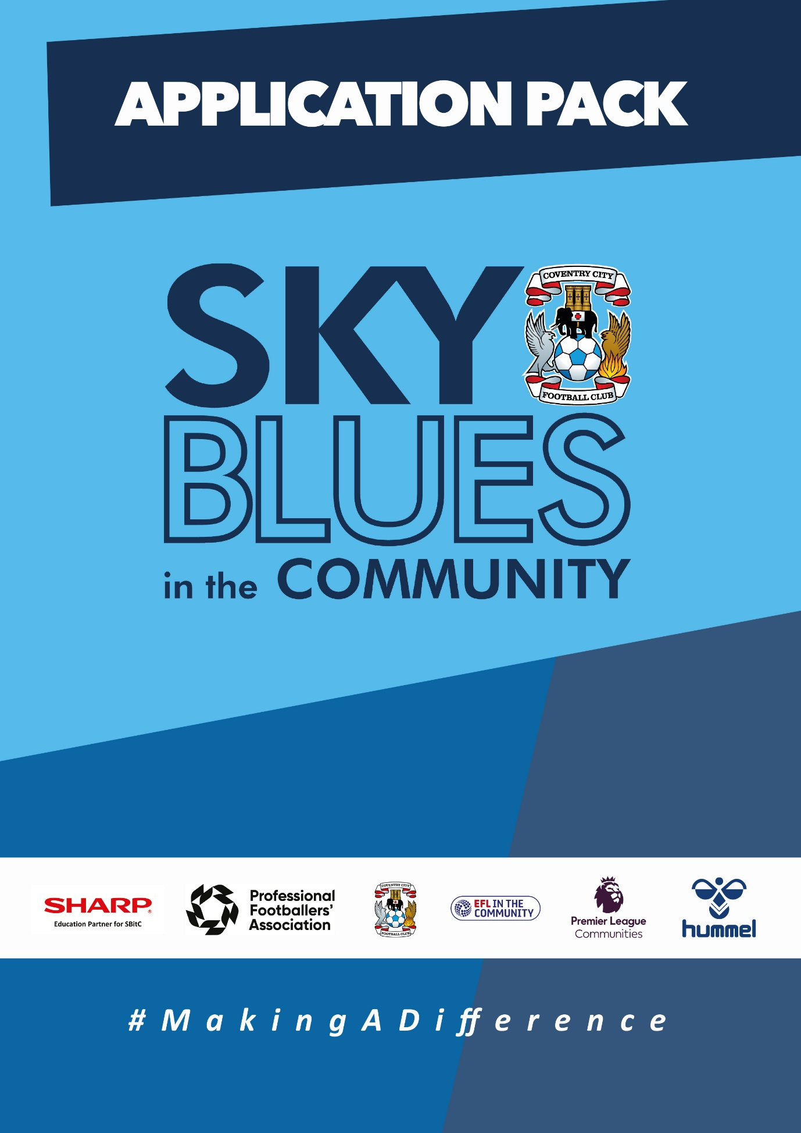

APPLICATION PACK
ABOUT US
Sky Blues in the Community is the official charity of Coventry City Football Club, proudly based at the Coventry Building Society Arena. Our mission is to harness the power of sport and physical activity, leveraging the unique influence and appeal of Coventry City Football Club to deliver impactful, high-quality community programs. Through strong partnerships and strategic alliances, we aim to empower individuals and communities across Coventry and Warwickshire.
Our work is driven by a commitment to social change and community empowerment. We provide inclusive and accessible opportunities to improve health and wellbeing, promote social inclusion, reduce crime, and enhance access to education and employment. Through these efforts, we aim to #MakeADifference across our city and county.
OUR STRATEGIC THEMES
Our work is structured around five core thematic areas, each with a distinct mission:
1. Health and Wellbeing
We are committed to addressing the health inequalities facing some of Coventry and Warwickshire’s most underrepresented communities. Through engaging, evidence-based programs, we support individuals to live healthier, happier lives, standing in partnership with organisations that share our vision for community wellbeing.
2. Education, Skills and Training
We aim to play a leading role in improving access to education, training, and employment opportunities. By inspiring confidence, providing practical tools and tailored support, we help individuals progress towards sustainable careers and lifelong learning.
3. Inclusion, Engagement and Participation
We are passionate about creating an active, inclusive, and cohesive community. Our programs provide opportunities for everyone—regardless of background, ability, or circumstance—to engage in physical activity in a welcoming, non-judgmental, and inspiring environment.
4. Sports Facilities and Community Assets
We are committed to enhancing the availability and quality of community spaces for sport and physical activity. By responding to the unique needs of our communities, we champion equitable access to inclusive, safe, and high-quality facilities that promote healthy lifestyles and social connection.
5. People and Infrastructure
Our people are our greatest asset. To sustain and grow our impact, we are investing in our team and our organisational infrastructure. We aim to ensure our workforce is reflective of our community and supported by continuous learning and development. We are committed to fostering a high-performing, inclusive, and purpose-driven working environment where everyone can thrive.

OUR VALUES
We expect all staff to embody our core values in everything they do:
- Community Focused
- Passionate
- Innovative
- Ambitious
- Inclusive

EQUALITY, DIVERSITY & INCLUSION
Sky Blues in the Community is committed to promoting equality, diversity, and inclusion across our workforce, services, and programs. We are dedicated to creating an environment where all individuals feel welcomed, respected, and empowered to reach their potential. We strive to embed inclusive practices throughout the organisation and challenge inequality wherever it arises.
SAFEGUARDING STATEMENT
We operate a person-centered approach to safeguarding. Where there are concerns about the welfare of a child or an adult at risk, we act in their best interests at all times. Sky Blues in the Community fully accepts its responsibility for safeguarding the wellbeing and safety of all individuals involved in our programs. All staff have a duty to create a safe, inclusive environment that protects children and adults at risk from harm. Safeguarding is everyone’s responsibility.



JOB DESCRIPTION
Job Title: | SBITC- Health and Wellbeing Coordinator | Reporting to: | SBITC Manager
Salary: | £28,000 per annum | Contract Type: | Full time (37.5 hours per week)
Location: | Across Coventry and Warwickshire | Days and hours of work: | Full time, with flexibility required including some evenings, weekends and public holidays
Document created: | April 2025 | Reference: | SBITC-HC

Purpose of the role:

The Health and Wellbeing Coordinator will lead on the planning, delivery and coordination of health and wellbeing programmes across Sky Blues in the Community's Health theme. Working as part of the Health and Wellbeing team, the post holder will deliver high-quality, person-centred health and physical activity interventions to a wide range of participants across Coventry and Warwickshire, working in partnership with local health, primary care and community organisations to improve health outcomes and reduce health inequalities.
The role sits above the Sports and Participation Coach in terms of responsibility and expectation, combining direct delivery with coordination, partnership management and monitoring and evaluation activity.

Key responsibilities (but not completely exclusive to):

Programme delivery and coordination
- Plan, deliver and evaluate a range of health and wellbeing sessions and interventions, including exercise referral, physical activity programmes, and health behaviour change support, tailored to the needs of individuals and groups.
- Lead on the coordination of health and wellbeing projects across Coventry and Warwickshire, ensuring delivery is high quality, consistent and aligned with SBitC's quality assurance framework.
- Work across diverse community settings including leisure centres, GP surgeries, community centres, parks and schools.
- Provide health and wellbeing coaching, advice and support to participants, including pre-screening and assessing suitability for physical activity programmes and prescribing appropriate exercise for a wide range of individuals.
- Motivate and support participants across multiple sessions, helping them to identify their needs, set goals and work towards personalised health and care plan objectives.
- Support the development of future health interventions and contribute to identifying new opportunities across partnerships and with key stakeholders.
Partnership and stakeholder management
- Build and maintain positive working relationships with key partners including primary care networks, social prescribers, GPs, community connectors, local authorities and voluntary sector organisations.
- Work with partners to ensure SBitC's health programmes support local and national strategies to improve health and reduce health inequalities.
- Promote SBitC's brand and ethos professionally across all partner and stakeholder relationships.
- Maximise opportunities to raise awareness of the organisation's activities across the health and wellbeing landscape.
- Monitoring, evaluation and administration
- Maintain accurate records including attendance registers, consent forms, risk assessments, incident and accident reports and outcome data.
- Monitor and evaluate programme activity using relevant systems, ensuring data is collected to the standard required by funders and commissioners.
- Contribute to impact reporting, case studies and funding evidence as required.
- Keep up to date with research and developments in public health, national service frameworks and physical activity.
People and organisational responsibilities
- Work as part of the Health and Wellbeing team, supervising, mentoring and supporting coaches and volunteers where appropriate.
- Work with managers and colleagues to support the design and development of health activities and programmes.
- Contribute to a culture of excellence and continuous improvement within the organisation.
- Undertake professional development as required by SBitC.
- Undertake any other duties reasonably required to ensure the effective delivery of SBitC programmes.
Safeguarding and organisational values
- Uphold and actively promote SBitC's commitment to safeguarding children and adults at risk in all aspects of delivery and partnership activity.
- Maintain an up-to-date knowledge of and adhere to SBitC's policies and procedures, including those relating to safeguarding, health and safety, data protection and emergency procedures.
- Champion SBitC's commitment to equality, diversity and inclusion across all aspects of the role.
- Complete all required safeguarding training and ensure it is kept current.
- Always represent SBitC and Coventry City Football Club in a professional manner.

Other requirements
- Full UK driving licence and access to a suitable vehicle. The role is based at the Coventry Building Society Arena with regular travel required across Coventry and Warwickshire.
- Subject to an enhanced DBS check.

PERSON SPECIFICATION
Job Title: Health and Wellbeing Coordinator
Essential
- Recognised industry health and fitness qualification at Level 2 or above, such as Fitness Instruction or Personal Training.
- Experience of planning, delivering and evaluating health and wellbeing or physical activity interventions, including pre-screening participants and prescribing appropriate exercise for a range of individuals.
- Experience of coordinating health or community programmes, including managing referral pathways or working alongside primary care or community health partners.
- Knowledge of key performance indicators and how they are used to monitor and improve programme delivery.
- Strong knowledge of safeguarding, health and safety, and equality principles, policies and procedures.
- Excellent interpersonal and communication skills, with the ability to engage and motivate a wide range of participants and work effectively with professionals including GPs, primary care staff, local authority officers and senior managers.
- Ability to support behaviour change and motivate individuals across a sustained programme of activity.
- Ability to plan, deliver and evaluate health, wellbeing and physical activity sessions to a high standard.
- Strong organisational and project coordination skills, with the ability to manage multiple programmes and priorities simultaneously.
- Competent user of Microsoft Office and relevant data management or monitoring systems.
- Emergency first aid qualification, to be held before start date.
- Full clean UK driving licence and access to a suitable vehicle.
- Willingness to work flexibly, including some evenings, weekends and public holidays, and to travel across Coventry and Warwickshire.
- Commitment to safeguarding children and adults at risk, and to equality, diversity and inclusion.

Desirable
- A degree in health development, sport, exercise science or a related field, or equivalent demonstrable experience in a health and wellbeing role.
- Activity on Referral qualification, such as Wright Foundation or equivalent.
- Mental health first aid qualification.
- Level 4 specialist instructor qualification, for example in falls prevention, cardiac rehabilitation, cancer rehabilitation, obesity or diabetes.
- Nutrition and weight management qualification.
- Awareness and understanding of social prescribing.
- Experience of writing health and wellbeing programmes and development plans tailored to individual and group needs.
- High standard of written communication including report writing, case study development and contributing to funding evidence.
- Knowledge of the local area and barriers to participation in physical activity across Coventry and Warwickshire.

Our values at SBiTC
At SBiTC, our values guide everything we do. We expect all applicants and colleagues to share and demonstrate these values in their daily practice:
- Acting with integrity, professionalism and confidentiality at all times.
- Remaining resilient, composed and solution-focused when faced with challenging behaviours.
- Demonstrating a positive, approachable manner and a genuine “can do” attitude.
- Being passionate about inclusion and committed to making a meaningful difference in young people’s lives.
- Showing enthusiasm, energy and adaptability, even under pressure.
- Upholding our commitment to safeguarding, equality, diversity and inclusion in every aspect of our work.

APPLICATION INFORMATION
Do you want to use sport and physical activity to make a genuine difference to people's health?
At Sky Blues in the Community, the official charity of Coventry City Football Club, we work across Coventry and Warwickshire to improve lives through sport, health, inclusion and education. Our Health and Wellbeing team delivers programmes that connect people to physical activity, support behaviour change, and reduce health inequalities in communities that need it most. This role sits at the heart of that work.
We are recruiting a Health and Wellbeing Coordinator to lead on the delivery and coordination of our health programmes across Coventry and Warwickshire. If you are an experienced health and wellbeing professional who understands exercise referral, behaviour change and community health delivery, and who wants a role with real variety and real impact, we would like to hear from you.
Why this role matters
Health inequalities across Coventry and Warwickshire are real and persistent. Our programmes exist to address them, using the reach and credibility of Coventry City FC to engage people who might not otherwise access support. This role is responsible for making those programmes work in practice, from coordinating delivery to managing the partnerships that sustain them, and capturing the evidence that keeps them funded.
What you will be doing
You will plan and deliver health and wellbeing sessions and physical activity interventions across a range of community settings, from leisure centres and GP surgeries to parks, community centres and schools. You will pre-screen and assess participants, prescribe appropriate activity, and support individuals across sustained programmes to set goals and make meaningful progress towards their health and care plan objectives.
Alongside direct delivery, you will coordinate programmes across the health and wellbeing portfolio, working with primary care networks, social prescribers, GPs, community connectors and voluntary sector partners to ensure our provision is joined up and effective. You will maintain accurate records, contribute to monitoring and evaluation, and help build the evidence base that supports future funding.
You will also play an active role in the team, mentoring coaches and volunteers, contributing to programme development, and identifying new opportunities to grow our health and wellbeing offer across the region.

What we are looking for
You will hold a Level 2 or above health and fitness qualification and have direct experience of delivering health and wellbeing or physical activity interventions, including working with referred or clinically complex participants. Experience of coordinating programmes and managing relationships with primary care or community health partners is essential, as is a confident, person-centred approach to supporting behaviour change.
Strong organisational skills, a high standard of record-keeping, and the ability to work flexibly across different settings and communities will all be important. An Activity on Referral qualification, mental health first aid, or a Level 4 specialist instructor qualification would be an advantage.
A full clean UK driving licence and access to a suitable vehicle are required. The role involves regular travel across Coventry and Warwickshire. A commitment to safeguarding children and adults at risk, and to equality, diversity and inclusion, is essential.
Why join us
You will be working under the banner of a professional football club that opens doors in communities where other organisations struggle to gain traction. The work is varied, the partnerships are meaningful, and the impact of what you do is visible in the communities you serve. If you want a health and wellbeing role with genuine purpose behind it, this is it.
How to Apply
To apply, please submit either:
- A CV and covering letter or
- A completed application form
Your application should clearly demonstrate how you meet the criteria outlined in the person specification.
Please send your application to us at: recruitment@sbitc.org.uk
Please note: You only need to submit either a CV and covering letter or a completed application form, not both.
Closing date for applications: 24th of May 2026
Please note that we may close the application process early if we receive a high number of applications, so early applications are encouraged.
If you require the application form in an alternative format, or if you would like to apply using a different method due to a disability or accessibility need, please contact us via 024 7678 6349 and we will be happy to discuss reasonable adjustments.
Safer Recruitment and Pre-Employment Checks
At Sky Blues in the Community, safeguarding is central to everything we do. We are committed to creating a safe and supportive environment for all staff, volunteers, and participants.
This role may involve working with children or adults at risk, and as part of our safer recruitment process, any offer of employment will be subject to:
- Two satisfactory references
- An enhanced Disclosure and Barring Service (DBS) check
- Confirmation of your identity and right to work in the UK

All staff are expected to follow our Safeguarding Policies and complete relevant training as part of their induction and ongoing professional development.
Diversity and Inclusion
Sky Blues in the Community is an equal opportunities employer. We welcome applications from all sections of the community and particularly encourage applications from individuals who are underrepresented in the sport and charity sectors. Appointments are made strictly on merit.
We are committed to providing an inclusive recruitment process. If you require any adjustments to complete your application or to attend an interview, please let us know.
We may collect anonymised equalities data from applicants for monitoring purposes only. This data will not form any part of the recruitment decision-making process.
Privacy Notice
Sky Blues in the Community is committed to handling your personal information responsibly and transparently. We comply with the UK General Data Protection Regulation (UK GDPR) and the Data Protection Act 2018 to ensure the privacy and security of your data.
Information provided during the recruitment process will be stored securely and retained for a period of six months after the closing date of the vacancy, unless a longer period is required by law or you consent to us retaining your details for future opportunities.
To request a copy of our privacy notice or exercise your data rights, please contact: sbitc@sbitc.org.uk.

