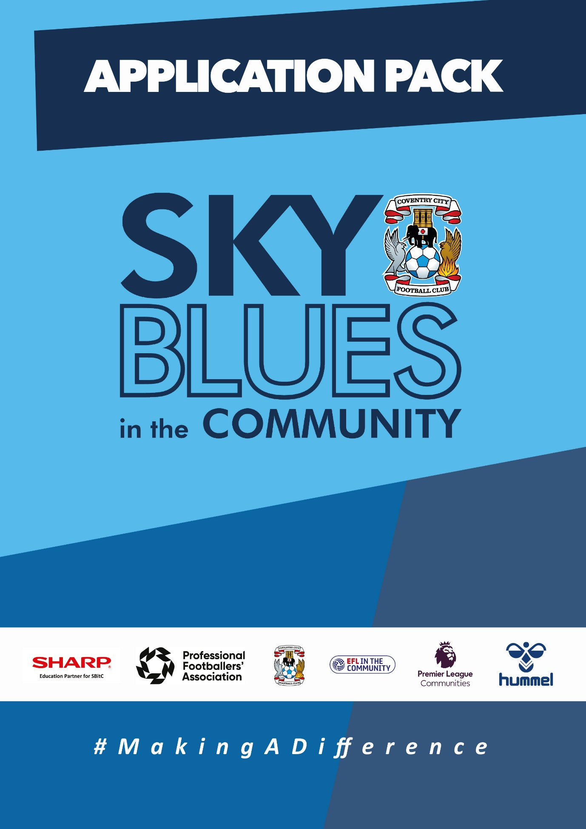

APPLICATION PACK
ABOUT US
Sky Blues in the Community is the official charity of Coventry City Football Club, proudly based at the Coventry Building Society Arena. Our mission is to harness the power of sport and physical activity, leveraging the unique influence and appeal of Coventry City Football Club to deliver impactful, high-quality community programs. Through strong partnerships and strategic alliances, we aim to empower individuals and communities across Coventry and Warwickshire.
Our work is driven by a commitment to social change and community empowerment. We provide inclusive and accessible opportunities to improve health and wellbeing, promote social inclusion, reduce crime, and enhance access to education and employment. Through these efforts, we aim to #MakeADifference across our city and county.
OUR STRATEGIC THEMES
Our work is structured around five core thematic areas, each with a distinct mission:
1. Health and Wellbeing
We are committed to addressing the health inequalities facing some of Coventry and Warwickshire’s most underrepresented communities. Through engaging, evidence-based programs, we support individuals to live healthier, happier lives, standing in partnership with organisations that share our vision for community wellbeing.
2. Education, Skills and Training
We aim to play a leading role in improving access to education, training, and employment opportunities. By inspiring confidence, providing practical tools and tailored support, we help individuals progress towards sustainable careers and lifelong learning.
3. Inclusion, Engagement and Participation
We are passionate about creating an active, inclusive, and cohesive community. Our programs provide opportunities for everyone—regardless of background, ability, or circumstance—to engage in physical activity in a welcoming, non-judgmental, and inspiring environment.
4. Sports Facilities and Community Assets
We are committed to enhancing the availability and quality of community spaces for sport and physical activity. By responding to the unique needs of our communities, we champion equitable access to inclusive, safe, and high-quality facilities that promote healthy lifestyles and social connection.
5. People and Infrastructure
Our people are our greatest asset. To sustain and grow our impact, we are investing in our team and our organisational infrastructure. We aim to ensure our workforce is reflective of our community and supported by continuous learning and development. We are committed to fostering a high-performing, inclusive, and purpose-driven working environment where everyone can thrive.

OUR VALUES
We expect all staff to embody our core values in everything they do:
- Community Focused
- Passionate
- Innovative
- Ambitious
- Inclusive

EQUALITY, DIVERSITY & INCLUSION
Sky Blues in the Community is committed to promoting equality, diversity, and inclusion across our workforce, services, and programs. We are dedicated to creating an environment where all individuals feel welcomed, respected, and empowered to reach their potential. We strive to embed inclusive practices throughout the organisation and challenge inequality wherever it arises.
SAFEGUARDING STATEMENT
We operate a person-centered approach to safeguarding. Where there are concerns about the welfare of a child or an adult at risk, we act in their best interests at all times. Sky Blues in the Community fully accepts its responsibility for safeguarding the wellbeing and safety of all individuals involved in our programs. All staff have a duty to create a safe, inclusive environment that protects children and adults at risk from harm. Safeguarding is everyone’s responsibility.



JOB DESCRIPTION
Job Title: | SBITC-Fundraising Manager | Reporting to: | SBITC-Head of Community
Salary: | £45,000 per annum | Contract Type: | Full time (37.5 hours per week)
Location: | SBITC Offices, CBS Arena, Coventry | Days and hours of work: | Monday to Friday, core hours between 0800 – 1800 (37.5 hours a week)
Document created: | April 2025 | Reference: | SBITC-FM1

Purpose of the role:

This is a senior individual contributor role that sits at the heart of SBitC’s financial sustainability and is a part of the SLT. Reporting to the Head of the Community, the Fundraising and Grants Manager will lead on securing the external income that funds our programmes, with responsibility for identifying, developing and submitting funding applications across all relevant streams, managing funder relationships, and ensuring full compliance with grant conditions and reporting obligations.
The postholder will have strategic responsibility for SBitC’s fundraising activity, working closely with the Head of Community, the Operations Manager and senior programme colleagues to shape and deliver a fundraising strategy aligned to organisational priorities. A particular emphasis of the role is football-sector funding, including the EFL Trust and Premier League Charitable Fund, alongside trusts and foundations, statutory and lottery sources, and other funders whose priorities align with our four pillars.
The role carries no line management responsibility. The postholder’s focus is wholly on income generation, pipeline development, funder stewardship and compliance. It acts as deputy to the Head of Community in all matters relating to external income.

Key responsibilities (but not completely exclusive to):

Fundraising Strategy
- Develop and deliver a fundraising strategy to maximise income across SBitC’s four pillars, identifying the funding mix required to sustain existing programmes and enable growth.
- Take responsibility for SBitC’s annual fundraising income budget, providing the Head of Community with regular forecasts and updates.
- Monitor the external funding landscape for new opportunities, including changes to EFL Trust and Premier League Charitable Fund priorities, lottery programmes, statutory sources, and relevant trusts and foundations.
- Advise the Head of Community on risks to existing income streams and emerging opportunities in sufficient time to respond effectively.

Bid Writing and Application Development
- Lead the drafting, development and submission of all grants and funding applications, ensuring bids are compelling, accurate, tailored to each funder’s criteria and aligned to SBitC’s strategic priorities.
- Work collaboratively with programme managers across Sport, Health, Inclusion and Education to gather the evidence, participant data, case studies and programme detail required to support applications.
- Ensure all submitted bids are fully costed and represent accurate full cost recovery, reviewed and agreed with the Head of Community prior to submission.
- Lead the development of consortia bids and partnership proposals where relevant, working with external organisations to build credible multi-partner applications.
- Maintain quality and consistency across all written submissions, presenting SBitC’s work and impact credibly and in a way that reflects the unique power of the football club platform.

Pipeline and Bid Management
- Maintain a live bid tracker covering all active applications, deadlines, decisions and renewal dates, shared with the Head of Community.
- Develop and manage a forward funding pipeline aligned to SBitC’s annual income targets, maintained at a value of at least 150% of target at all times.
- Ensure new business opportunities are assessed against SBitC’s values and strategic plan before applications are pursued, and that a full cost recovery budget accompanies every new bid.

Funder Relationship Management
- Develop and maintain strong working relationships with key funders, acting as SBitC’s primary point of contact for EFL Trust, Premier League Charitable Fund and other significant income relationships.
- Represent SBitC at funder meetings, site visits, conferences and relevant external forums.
- Develop and maintain a stakeholder engagement plan for funders and prospects, identifying how each relationship should be maintained and developed over time.
- Manage funder expectations proactively, communicating any changes to programme delivery, outputs or timescales in a timely and professional manner.

Reporting and Compliance
- Ensure all funder reporting obligations are met on time and to the required standard, producing narrative and financial reports, impact summaries and progress updates as required.
- Maintain a reporting calendar and alert programme and finance colleagues to upcoming deadlines in sufficient time to compile accurate returns.
- Take responsibility for statutory income and expenditure budgets associated with funded programmes, working with the Financial Coordinator to ensure accurate financial reporting to funders.
- Ensure grant conditions are understood by relevant colleagues and that delivery remains compliant with funder requirements throughout each funded period.
- Oversee database management and record-keeping in relation to funding applications and funder correspondence.

Impact Evidence and Data
- Work with programme managers to ensure that data collection processes capture the outputs and outcomes required to satisfy funder reporting and to build the evidence base for future applications.
- Develop and maintain a library of case studies, participant statistics and impact evidence that can be drawn upon across bids and reports, reflecting the breadth of SBitC’s work across all four pillars.
- Contribute to consortia applications and partnership bids where SBitC’s evidence base strengthens a wider proposal.

Safeguarding and Organisational Values
- Uphold and actively promote SBitC’s commitment to safeguarding children and adults at risk in all funding activity, ensuring all applications and funder-facing communications reflect organisational policies and values.
- Champion SBitC’s commitment to equality, diversity and inclusion in the development of bids and in the relationships maintained with funders.
- Complete all required safeguarding training and ensure it is kept current.

PERSON SPECIFICATION
Job Title: Fundraising Manager

Essential
- Demonstrable experience of securing significant income through grant applications and fundraising, including six-figure grants, from trusts, foundations, lottery bodies or statutory funders.
- Experience of working with football-sector funders, including EFL Trust or Premier League Charitable Fund, or strong and evidenced ability to develop these relationships quickly.
- Experience of leading funder relationships at a senior level, including reporting, stewardship and representing an organisation externally.
- Ability to develop and manage statutory income and expenditure budgets and to produce accurate financial returns to funders.
- Excellent written communication skills, with the ability to produce compelling, accurate funding applications and impact reports tailored to different funder audiences.
- Strong planning and organisational skills, with experience of managing multiple bids, deadlines and funder relationships simultaneously.
- Ability to work collaboratively with programme and finance colleagues to gather evidence and develop fully costed proposals.
- Understanding of the community sport and charity sector, and of the funding landscape relevant to sport, health, inclusion and education programmes.
- Commitment to safeguarding children and adults at risk, and to equality, diversity and inclusion.

Desirable
- Experience of working within a football club community programme or EFL or Premier League club charity.
- Experience of developing consortia bids and managing partnership funding arrangements.
- Knowledge of impact measurement frameworks relevant to community sport, health and education programmes.
- Familiarity with the specific programmes and funding streams operated by EFL Trust and the Premier League Charitable Fund.
Behaviours
- Acts with integrity, confidentiality and professionalism at all times.
- Resilient and composed when dealing with challenging behaviours.
- Positive, approachable manner with a genuine “can do” attitude.
- Passionate about inclusion and making a difference in young people’s lives.
- Enthusiastic, energetic and adaptable under pressure.
- Commitment to safeguarding, equality, diversity and inclusion.

Performance-Related Bonus Structure
A minimum annual fundraising target of £200,000 of secured new income applies to this role. This target excludes renewable funding, defined as income secured through the renewal or continuation of an existing grant where SBitC is the incumbent and no competitive application was required. No bonus is payable unless and until the minimum target has been met in full.
Once the minimum target is secured, the bonus structure opens up progressively, rewarding performance above the £200,000 floor at increasing rates. The bonus is calculated as a percentage of the postholder’s base salary, paid as a flat payment at whichever band is achieved.
“Secured” means confirmed in writing by the funder, with a grant agreement or equivalent issued. Applications submitted but not yet confirmed do not count toward the threshold in the year of submission.

Performance Band | Income Secured (new, non-renewable) | Bonus Payable | Indicative Payment (at £45k)
Below minimum target | Below £220,000 | Nil | –
110% of target | At least £220,000 | 1% of base salary | £450
125% of target | At least £250,000 | 2.5% of base salary | £1,125
150% of target and above | At least £300,000 | 4% of base salary | £1,800

The bonus is calculated on base salary at the point of payment and is paid in a single payment following the annual target review, ordinarily within 30 days of the close of the financial year. It is subject to tax and National Insurance in the usual way. The bonus is discretionary and not contractually guaranteed in any year in which the annual target has not been formally set and agreed in writing. The Head of Community retains discretion to adjust the target in-year where there is a material change in the organisation’s circumstances, subject to reasonable notice to the postholder.

APPLICATION INFORMATION
Do you believe that sport has the power to change lives, and that securing the right funding is what makes that possible?
At Sky Blues in the Community, the official charity of Coventry City Football Club, we use the power of football to connect communities, tackle inequality, support wellbeing, and create opportunities across Coventry and Warwickshire. Every day our programmes make a difference to children, families, older adults, young people at risk and people facing disadvantage. Your work in this role will be what keeps those programmes going and helps them grow.
We are recruiting a Fundraising and Grants Manager to lead our income generation activity. If you are passionate about securing funding that creates real-world impact, skilled at developing compelling applications and experienced at building relationships with funders, this is a role where your expertise will be felt directly in communities across Coventry and Warwickshire.

Why this role matters
Our programmes only exist because of the funding that supports them. Premier League Kicks keeps young people safe on Friday nights. Walking Football for Parkinson’s gives people with neurological conditions a place to stay active and connected. Premier League Primary Stars and Inspires reach thousands of children in schools across our region.
Behind every one of those programmes is a funding application, a funder relationship and a compliance obligation. This role is responsible for all of it. The Fundraising and Grants Manager will shape SBitC’s income strategy, lead on bids to the EFL Trust, the Premier League Charitable Fund and a wide range of trusts, foundations and statutory bodies, and ensure we meet every reporting and compliance commitment we make to our funders.
This is a senior, strategic position with a direct line to the Head of Community and a meaningful stake in the organisation’s future.

What makes this opportunity unique
You will be based at the Coventry Building Society Arena, home of Coventry City Football Club, with access to one of the most compelling community stories in the EFL and Premier League. The breadth of our programmes across Sport, Health, Inclusion and Education means there is rarely a funding opportunity that does not connect to something we deliver.
You will work across all four of our strategic pillars, supporting programme managers to articulate the impact of their work and translating that impact into applications that secure the income we need. You will have the freedom to shape our fundraising strategy, build our pipeline and develop funder relationships that last.
The role includes a performance-related bonus. Once you have secured £200,000 of new income in a year, the bonus structure opens progressively, reaching up to 4% of base salary for exceptional performance. This is a genuine incentive that recognises the direct contribution this role makes to the charity’s sustainability.

What you will do
Your work will shape how SBitC sustains and grows its charitable activity. The role focuses on four main areas.

Income Generation and Strategy
Leading our fundraising strategy across all four pillars, building and managing a live pipeline of applications to EFL Trust, Premier League Charitable Fund, lottery bodies, trusts, foundations and statutory funders. You will set and own our annual income targets and keep the Head of Community fully sighted on progress, risks and opportunities.

Bid Writing and Application Development
Taking the lead on all grant applications, from identifying the opportunity to submitting a compelling, fully costed bid. You will work closely with programme managers across our teams of: Sports Facilities and Community Assets, Health and Wellbeing, Social Inclusion and Community Cohesion and Participation and Education Training and Employment; to build the evidence base, and you will ensure every application we submit reflects the quality and ambition of the work we do.

Funder Relationships and Stewardship
Acting as SBitC’s primary contact for our key funders, attending meetings, representing the charity at external forums, and managing every relationship with the professionalism and consistency that builds long-term trust. You will develop a stakeholder engagement plan that ensures no funder relationship is left to chance.

Reporting, Compliance and Impact
Ensuring we meet every funder reporting obligation on time and to the required standard. You will maintain a reporting calendar, oversee financial returns to funders in partnership with our Financial Coordinator, and work with programme teams to capture the impact data that makes our next application stronger than the last.

What we are looking for
We are looking for someone with a genuine track record of securing significant income through grants and fundraising, including six-figure awards. You will have experience of leading funder relationships at a senior level and the written communication skills to produce applications that stand out.
Experience of working with football-sector funders, including EFL Trust or the Premier League Charitable Fund, is an advantage, as is a background in community sport, health or education programmes. What matters most is that you understand the funding landscape, you know how to build a pipeline and manage it, and you can work collaboratively with colleagues to turn programme delivery into compelling evidence.
A commitment to safeguarding children and adults at risk is essential, as is a genuine belief in the power of sport to change lives.

Why you will enjoy working here
This role offers the rare combination of a competitive salary for the charitable sector, a meaningful performance bonus, and work that you can see making a difference in real communities. You will be part of a small, dedicated team where your contribution is visible and valued, operating under the banner of a professional football club that gives our charity a reach and credibility that very few organisations can match.
The experience you gain here will strengthen your professional profile across the fundraising, community sport and charity sectors. You will build relationships with some of the most significant funders in football and community sport, and you will have the scope to shape how SBitC grows its income for years to come.

How to Apply
To apply, please submit either:
- A CV and covering letter or
- A completed application form
Your application should clearly demonstrate how you meet the criteria outlined in the person specification.
Please send your application to: David Busst at recruitment@sbitc.org.uk
Please note: You only need to submit either a CV and covering letter or a completed application form, not both.
Closing date for applications: 20th of May 2026
Please note that we may close the application process early if we receive a high number of applications, so early applications are encouraged.
If you require the application form in an alternative format, or if you would like to apply using a different method due to a disability or accessibility need, please contact us via 024 7678 6349 and we will be happy to discuss reasonable adjustments.
Safer Recruitment and Pre-Employment Checks
At Sky Blues in the Community, safeguarding is central to everything we do. We are committed to creating a safe and supportive environment for all staff, volunteers, and participants.
This role may involve working with children or adults at risk, and as part of our safer recruitment process, any offer of employment will be subject to:
- Two satisfactory references
- An enhanced Disclosure and Barring Service (DBS) check
- Confirmation of your identity and right to work in the UK

All staff are expected to follow our Safeguarding Policies and complete relevant training as part of their induction and ongoing professional development.
Diversity and Inclusion
Sky Blues in the Community is an equal opportunities employer. We welcome applications from all sections of the community and particularly encourage applications from individuals who are underrepresented in the sport and charity sectors. Appointments are made strictly on merit.
We are committed to providing an inclusive recruitment process. If you require any adjustments to complete your application or to attend an interview, please let us know.
We may collect anonymised equalities data from applicants for monitoring purposes only. This data will not form any part of the recruitment decision-making process.
Privacy Notice
Sky Blues in the Community is committed to handling your personal information responsibly and transparently. We comply with the UK General Data Protection Regulation (UK GDPR) and the Data Protection Act 2018 to ensure the privacy and security of your data.
Information provided during the recruitment process will be stored securely and retained for a period of six months after the closing date of the vacancy, unless a longer period is required by law or you consent to us retaining your details for future opportunities.
To request a copy of our privacy notice or exercise your data rights, please contact: sbitc@sbitc.org.uk.

